Regulatory Authorisation and Documented Access to Cryptoasset Services
Vladislav Ch
Project affiliation: Holder.io
Research revision V3, 2 November 2026. The empirical reference date remains 30 October 2026; V2 evidence was collected on 30–31 October. The V2 preprint was publicly released on 1 November 2026. This revision adds legal analysis, an audit of retained data and sensitivity analysis; it is not a new market census. No independent external peer review or DOI is claimed.

Abstract
Regulatory authorisation identifies a provider's legally permitted activities but does not, by itself, establish a particular customer's contractual admission or successful use of a service. This article proposes a standard for preserving legal scope when deriving access statements: match the legal person, regulatory route, service, territory, customer predicates and operative time, and disclose unresolved links. The doctrinal argument is developed principally from the EU Markets in Crypto-Assets Regulation, with Canadian individual decisions and operator documents illustrating distinct limits. A purposive documentary dataset covers twenty platform surfaces, ten jurisdictions and six service families, or 1,200 fixed queries. The retained V2 annotations contain 12 available, 273 unavailable, 187 restricted, 718 unknown and ten inaccessible responses. Repeating one optimal country-level category across six services disagrees with at least 185 recorded statuses. This measures loss of stored annotation information, not legal error or actual access. Unknown and inaccessible responses account for 60.67% of the grid. Under a hypothetical completion that holds the 472 substantive annotations fixed, heterogeneous pairs range from 32 to 199 out of 200; the data therefore do not identify the prevalence of real service heterogeneity. A complete computational audit and renewed source review are reported separately. The proposed standard operationalises bounded inferences from legal evidence; it does not establish a universal right of admission, a new statutory duty for every comparison website, or misconduct by the sampled firms.
Keywords: cryptoasset services; regulatory authorisation; contractual eligibility; MiCA; documentary evidence; missing data; reproducibility.

1 Introduction
A platform may be described as “licensed in Europe” while a resident still cannot use a particular product. The apparent inconsistency disappears when three propositions are separated: a legal person is permitted to provide specified activities; that person offers a service to a defined customer under operative terms; and the customer can actually complete the relevant operation. Each proposition requires different evidence. Substituting a brand name, a licence badge or a country label for these separate propositions can change the meaning of a legally accurate source.
The legal thesis of this article is that customer-access representations derived from regulatory records should preserve the scope of the legal authority on which they rely. An authorisation can support an affirmative proposition only within its person, activity, territorial and temporal limits. A further claim about a customer's eligibility requires applicable contractual and product evidence. This is a proposed standard of justified inference. Part of its legal motivation comes from MiCA's service-specific authorisation scheme and its information duties for cryptoasset service providers; applying the standard to independent research catalogues is a methodological recommendation, not an assertion that those catalogues automatically owe the same statutory duties.
The distinction has practical legal consequences. Treating AML registration as broad product approval misstates the kind of instrument. Applying one group company's permission to another omits the regulated person. Treating freedom to provide authorised services across the Union as guaranteed customer admission confuses the provider's regulatory position with a customer's contract. Conversely, a missing register field does not establish an unlawful service, and a contractual refusal does not, without further analysis, establish a legal prohibition. Section 9 develops these propositions from primary authorities and addresses exceptions and counterarguments.
The empirical component asks a narrower question: what information about six service families is lost if a platform–country pair receives a single repeated status? The fixed frame comprises twenty platform surfaces and ten jurisdictions. It records the documentary answer for a specified adult retail profile, while preserving unknown and inaccessible answers. It is not a test of live onboarding or trading and does not rank providers. A legal interpretation and a stored annotation are separately contestable.
The contribution has three parts. First, the article articulates a service- and entity-specific inference standard and identifies its doctrinal boundaries. Second, it demonstrates a precise loss of annotation information under a defined single-label representation, with explicit sensitivity to incomplete evidence. Third, it provides a dated, auditable research record, including corrections, unresolved source routes and reproducible calculations. It makes no claim to be the first geographic exchange catalogue or to establish universal compliance rates. The numerical experiment motivates more careful representations; it does not prove that every observed documentary difference breaches a legal duty.
V1 and V2 remain identifiable historical stages. V2 changed only two Kraken derivatives responses and did not comprehensively recode the other 1,198 queries. V3 examines retained records, revises legal analysis and records the scope of renewed source checking without recasting an unchanged historical label as a freshly observed market fact. This separation permits corrections without concealing the limitations of the underlying collection.

2 Related research and measurement boundaries
Prior research establishes several neighboring objects of measurement. The Cambridge benchmarking study by Blandin et al. (2020) combines industry surveys with other data. Its 280 entities in 59 countries describe the survey contributions; its geographic user-ban figure has a separate source, the 21Shares Crypto Exchanges Database. Conflating those denominators would misdescribe both the earlier study and the present precedent. The report demonstrates that industry geographic data have already informed research, not that a later dataset inherits academic validation.
The closest documentary comparator is Ordekian et al. (2025), who analyzed 143 documents from 75 exchanges, selected from 138 candidates. Their documents were collected in November 2022 and assessed against governance and security criteria associated with MiCA and DORA. Publication year therefore differs from the observation period. Their iterative coding process explicitly reports that inter-rater reliability was not calculated (§ 3.2.2, p. 5). That study assesses governance, custody, cybersecurity and liability criteria. The present study addresses the separate inference from a scoped regulatory or contractual statement to a fixed customer–service query; it does not repeat their compliance scoring. Both approaches require separating published provisions from implemented practices.
Market studies address a further distinction. Makarov and Schoar (2020) study trading and arbitrage; selected passages of the December 2018 working version were inspected alongside final-publication metadata. Price segmentation can be consistent with access frictions, but does not uniquely identify a contractual exclusion. Likewise, the historical investor constraints discussed in the working paper by Crépellière, Pelster and Zeisberger (2022) cannot be audited using present-day terms alone. Eligibility data could support future backtests only when evidence is matched to the period and investor definition being simulated.
Regulatory communication and business lifecycle are also distinct from current eligibility. Auer and Claessens (2018) analyze market reactions to regulatory news, an object that differs from an operator's contractual effective date. The exchange-closure analysis of Moore, Christin and Szurdi (2018) concerns historical operational survival, not a current resident's access to a particular service. These differences motivate separate fields for announcements, effective intervals, observation dates and account phases rather than one undifferentiated “last updated” value.
Dataset methodology supplies complementary principles. Gebru et al. (2021) organize documentation around a dataset's motivation, composition, collection, processing, uses, distribution and maintenance. The FAIR principles emphasize reusable scientific data, while PROV-Overview distinguishes the entities, activities and agents involved in production. These frameworks motivate explicit lineage; neither a filled documentation form nor a provenance record certifies factual correctness. Similarly, the Data Quality Vocabulary describes quality assessments without prescribing one universal definition of fitness for purpose.
The literature search was targeted and critical, not a systematic review. The source register records reading depth, including author versions, selected passages, abstracts and indexed-only material. Transparency practices associated with PRISMA 2020 inform reporting, but no claim of PRISMA-compliant exhaustive retrieval is made. This distinction prevents a broad title or a large bibliography from standing in for a verified search population.

3 Study design and sources
This section records the V1 sampling and collection protocol. V2 retains its reference profile and adds the audit described in Section 7.

3.1 Sampling frame and reference profile
The sample contains Binance Global, Bybit Global, OKX Global, Bitget Global, KuCoin Global, Kraken, Coinbase, Crypto.com Exchange, Gemini, Bitstamp, Bybit EU, OKX Europe, Binance.US, Bitvavo, Bitpanda, Gate Global, HTX Global, MEXC Global, Bitfinex and bitFlyer Japan. These are platform slots, not 20 independently verified legal operators. Global and regional surfaces remain separate. “Centralized exchange” is an operational umbrella that includes centralized broker/exchange services; it does not assert that every slot is legally classified as a trading venue.
The jurisdictions are the United States, United Kingdom, Germany, France, Japan, Singapore, United Arab Emirates, Canada, Russia and India. Selection was purposive, intended to expose contrasting geographic, regulatory and regional-routing conditions. Germany and France permit observation of shared European documents without treating them as independent regulatory experiments. No claim is made that the ten jurisdictions represent the world, that slots are weighted by users or volume, or that the sample provides a ranking of customer convenience.
The six service families are onboarding, spot trading, retail cryptoasset derivatives, fiat services, explicit staking and cryptoasset withdrawal. Fiat includes distinct funding, withdrawal and payment routes, retained as subservice conditions. Generic Earn or lending language is not automatically coded as staking, and spot margin is not automatically classified as a derivative. The reference profile is an adult individual retail customer with known actual residence in the selected country. Onboarding concerns a new account; the other five queries concern an existing account. Citizenship, physical location, registered account geography and legally defined tax residence are not silently filled from actual residence.
Ordinary verification and account requirements are recorded but do not, by themselves, create a country-specific restricted state. Explicit geographic qualifications are different. A citizenship exclusion or a continuing legal-residence representation changes the set of people to whom an affirmative statement applies. The design therefore avoids treating an unspecified attribute as satisfied merely because a registration interface is visible or the customer is resident in the named country.

3.2 Protocol history and collection
The platform frame was specified before new empirical collection. The local protocol was not preregistered. The team already knew aggregate characteristics of the Holder corpus and selected policy examples. An initial timestamp was subsequently corrected: it represented drafting start rather than an independently logged file freeze. The complete protocol file was created after a qualitative pilot involving four documents and before full aggregation. That pilot was not completed annotation of a 240-cell submatrix. Later scope clarifications, including the treatment of named operators and legal-residence predicates, were recorded after selected or complete outcomes had been seen.
Collection prioritized operator terms, service-specific support documents and official migration or closure notices. Regulatory documents supplied context and identity evidence, not automatic permission to use a service. Literature and industry-methodology sources supported comparison and measurement design. Retrieval failures, empty pages and pointers were retained. A readable general page did not make an inaccessible product contract readable, and no alternative slot was substituted to improve coverage.
The core external collection contains 206 observations at 183 exact registered URLs. Of these observations, 169 involved substantive direct reading of relevant text; this does not imply complete reading of every document. Seventeen temporal-review rereadings and 28 later semantic-review rereadings introduce no new registered URLs. Thus the combined evidence-note index has 251 observations, including 45 internal reviews. Later bibliographic and editorial quality-assurance readings are logged separately and are not retrospectively added to the frozen research registries. The integrated core-plus-temporal registry has 223 records, a different count that is retained for provenance rather than retrospectively relabeled.
Table 1. V1. Units and denominators in the research package. Counts refer to the observation date of 30 October 2026 unless a separate historical corpus is specified; they must not be added as independent confirmations.
Layer | Count | Meaning
Platform slots | 20 | Prespecified service surfaces, not necessarily distinct legal entities
Platform–country pairs | 200 | Units for six-service compression analysis
Query cells | 1,200 | Fixed coverage denominator
Atomic rules | 154 | Coherent source-level policy statements
Core source observations | 206 | Includes reading and retrieval limitations
Internal review observations | 45 | Repeated reading, no new exact registered URLs
Exact registered URLs | 183 | Conservative address identity, not content independence
Distinct substantive-read URLs | 150 | Declared text-reading endpoints, including read versions

The scholarly register contains 18 works, including 15 with substantive selected-text readings, two with abstract/metadata readings and one with indexed-only reading. The original Holder corpus was audited separately: 231 dossiers contained 475 country rules, which expanded into 4,689 rule–country rows and 2,892 unique platform–country pairs. Those rows arose from an opportunistic research process and are not substituted into the new fixed denominator. A mismatch with an older counter was reconciled to a preserved local KuCoin revision, rather than interpreted as a change in external market policy.

4 Representation, annotation and provenance
The V1 representation is retained. V2 augments provenance and applies two explicit patches; unmodified cells are not newly validated.
The representation separates four entities. A source observation identifies a URL, reading depth, observation date and saved evidence note. An atomic rule records a coherent statement with its operator, geographic basis, product, cohort, conditions and temporal scope. An identity record preserves candidate legal routes without asserting their applicability to every customer. A query cell records the answer supported for the fixed profile. The same rule may support several cells; a cell may also retain a source bundle without a mapped rule when the bundle does not resolve the query.
Six statuses are permitted. Available and unavailable are categorical documentary responses. Restricted retains a material condition or service subdivision whose relevance depends on unspecified attributes. Unknown records insufficiently established scope or evidence. Inaccessible records an obstructed relevant evidence path. Conflicting is reserved for unresolved opposing evidence within matched scope; different products, dates or cohorts alone do not create a conflict. No final query cell is coded conflicting, which does not establish agreement among all external documents.
Affirmative query-level availability requires an applicable named contracting operator. A positive platform-level statement can still be retained as an atomic fact when the legal route is unresolved, while the exact query remains unknown. The evidential threshold is asymmetric: an unambiguous platform prohibition can be recorded without claiming a fully resolved legal entity. This threshold was explicitly clarified during collection. Its effect is to avoid turning identity gaps into either permission or country bans, rather than to reward a particular platform.
Geographic fields preserve source predicates independently of the reference query. Residence, citizenship, location and incorporation are not merged, and a list of bases does not imply a Boolean conjunction or disjunction. Conditional outcomes retain their own predicate and status. A branch's existence is not evidence that its predicate holds for the reference customer. Nor is the set of recorded branches assumed exhaustive or mutually exclusive. Missing logical metadata remains null, instead of being inferred from the presence of prose.
Temporal fields distinguish document dates, effective boundaries, observation dates and relative account events. When only a reading date was retained, no exact request time was fabricated. A batch-start timestamp is not treated as the time of every individual retrieval. Announced future changes remain future statements; a passed historical date does not automatically establish a continuing recovery channel. Equally, a document is not declared expired merely because it is old. Applicability requires attention to the source's genre, operative scope and any explicit continuity, not a universal age cutoff.
Normalization preserves original records, record hashes and input-file hashes. Semantic corrections are applied through a separate authorized overlay with before-and-after values and supporting notes. Nineteen record patches form the final overlay; this count includes changes to conditions and locators, not only changes of status. An additional mechanical alias correction restored conditional predicates recorded under the key “if.” The hash of a saved paraphrase authenticates those local bytes, not the remote web page or the completeness of reading. Full third-party pages were not systematically archived for redistribution.

5 Evaluation strategy
This evaluation was defined on V1. Section 7 reports the V2 recalculation separately.
Let V(p) denote the ordered vector of six recorded statuses for platform–country pair p. The analysis first measures whether V(p) contains more than one status. Because this includes differences in knowledge, a second measure retains only available, unavailable and restricted cells, and restricts its denominator to pairs with at least two such responses. The analysis is repeated for the five existing-account services to distinguish product variation from the new-account versus existing-account contrast. These are descriptive properties of the dataset, not independent trials of access.
A conservative country summary is allowed to abstain. It emits a common status when all six agree; otherwise an explicit conflict takes precedence, followed by a conditional summary when a restricted cell or multiple substantive statuses occur. Remaining unresolved mixtures become unknown. A strict inverse decoder asks which service status is guaranteed by that summary across all 6⁶ possible input vectors. It returns a value only when every possible preimage agrees. This measures the guarantee of this particular encoding, not the usefulness of a linked country page or the quality of an analyst's explanation.
A favorable alternative is a homogeneous-vector certificate: emit the shared status when all six positions agree, and otherwise abstain. Its non-abstaining labels can be broadcast to recover the complete status vector exactly. Unlike a categorical access claim, even an all-unknown vector can therefore be recovered. Neither decoder restores operator identity, branch predicates, sources or temporal boundaries. Those are separate dimensions of information loss, not additional independent observations that can be multiplied into the sample size.
A third comparator does not require choosing a conservative encoding. An oracle sees the entire vector and repeats its most frequent status across the six services. If n(p, s) is the frequency of status s in pair p, the minimum number of disagreements in this narrow class is 6 − max_s n(p, s). The sum is compared with 1,200 retained status positions. This is a mathematical lower bound on disagreements for mandatory repetition of one of the six categories. It is not an empirical prediction error, an external accuracy benchmark or an optimum over arbitrary information encodings.
Conditional branch differences are counted only as storage properties. They are not combined across incompatible predicates to manufacture service contrasts. A small set of explanatory traces was selected after inspection, including one matched-predicate comparison for Bybit's UK-registered existing accounts. Such traces demonstrate how the representation works, but are not a random validation sample. No kappa, alpha, confidence intervals for world prevalence, causal effects or monetary benefits are estimated. The distinction between agreement and validity follows the methodological caution developed by Artstein and Poesio (2008), while shared-source dependence is treated as a design concern rather than ignored by counting expanded rows.

6 Frozen V1 results
The tables and figures in this section report frozen V1 values. Revised V2 results appear in Section 7.

6.1 Documentary coverage and missing scope
The final grid contains 12 available, 273 unavailable, 185 restricted, 720 unknown and ten inaccessible cells. Categorical responses account for 285/1,200, or 23.75%. Conditional responses account for another 15.42%. Their combination is 470/1,200, or 39.17%, but is not full resolution or unconditional eligibility. The remaining 730 cells are epistemic abstentions. The small number of affirmative cells reflects both the chosen profile and conservative scope requirements; it must not be read as evidence that only one percent of real customers can use an exchange.
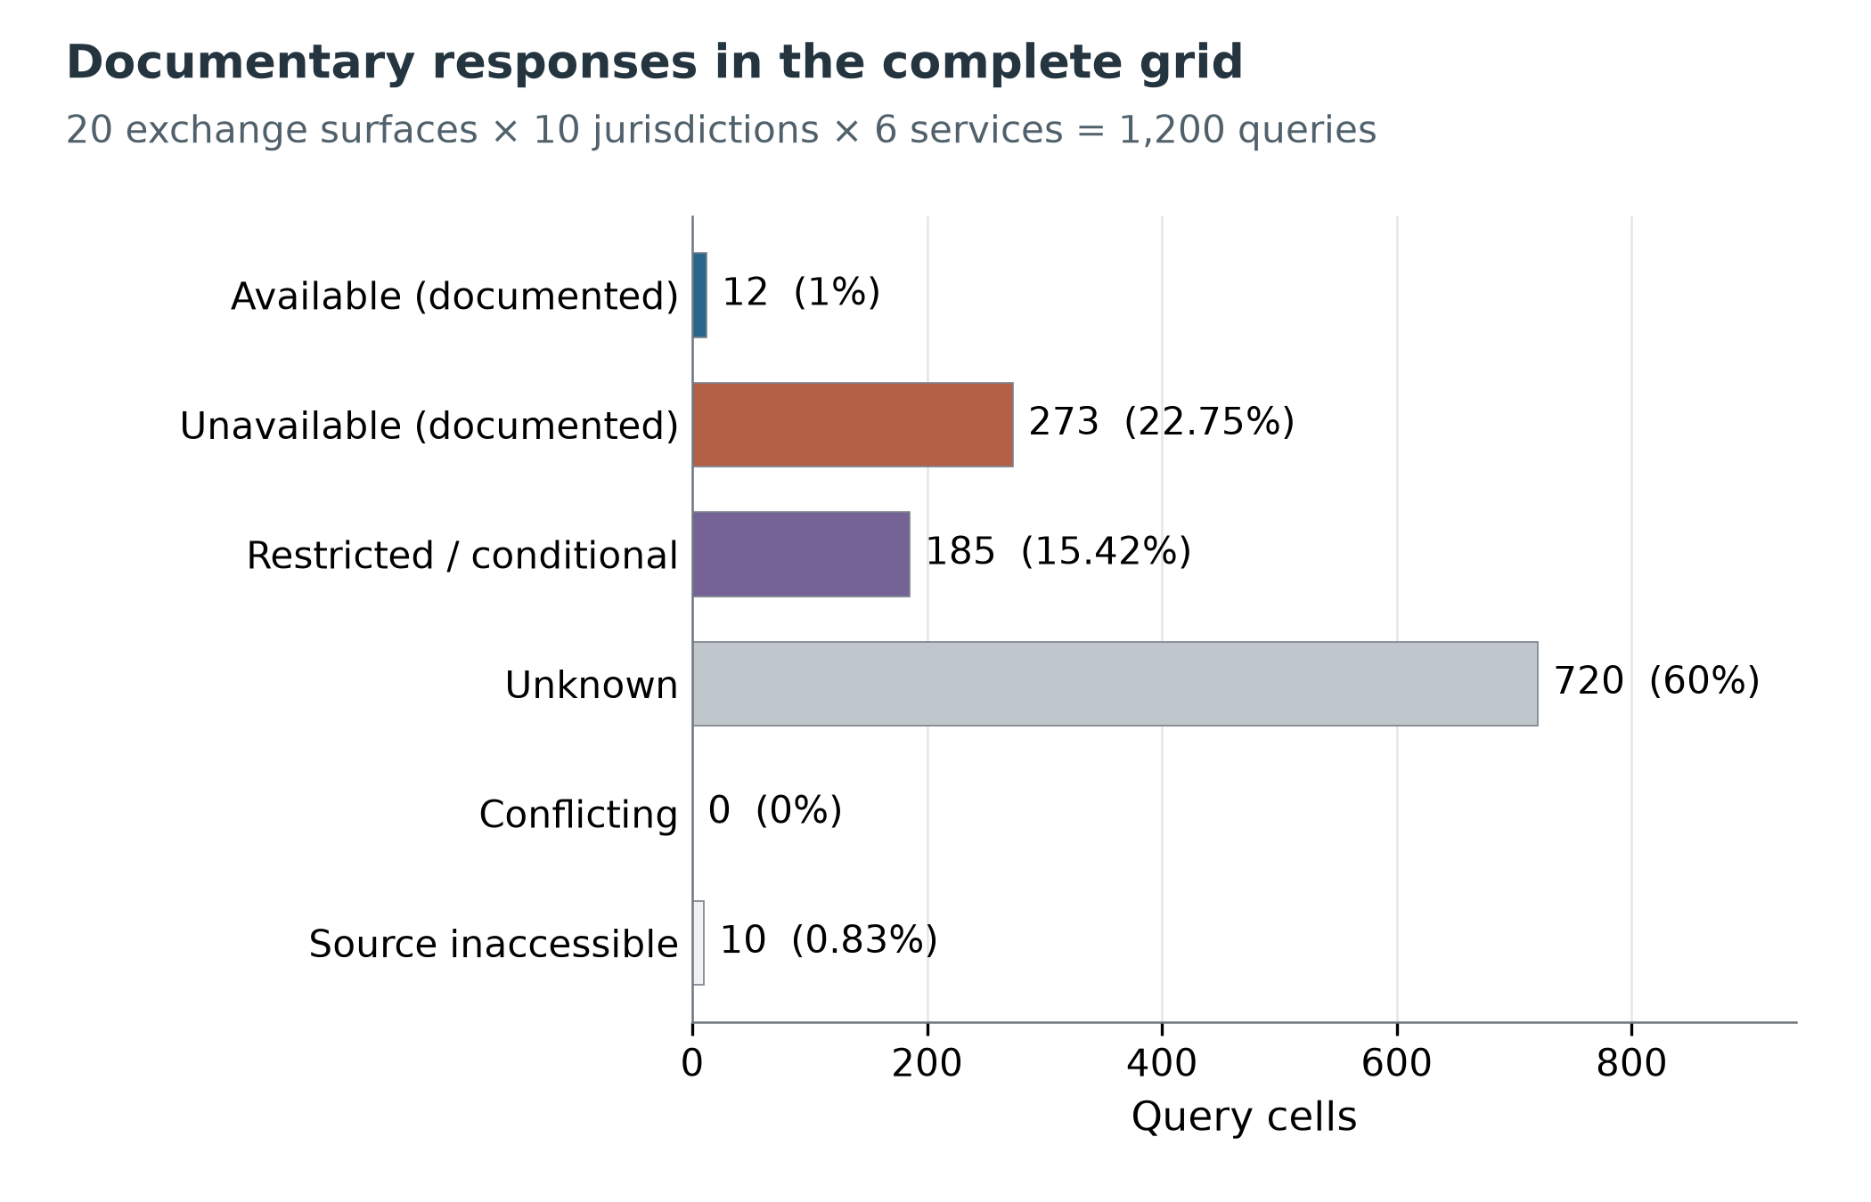
Figure 1. V1. Documentary responses in the complete grid. The denominator is 1,200 fixed queries across 20 platform surfaces, ten jurisdictions and six services, observed on 30 October 2026. Statuses describe the specified adult retail resident profile; restricted preserves conditions and unknown is not permission. No live account outcomes were measured. Data: normalized-v6 cells; English variant of study figure fig05.
Onboarding has 103 categorical or conditional responses among 200 queries, whereas cryptoasset withdrawal has 32. Withdrawal also has 168 unknown cells and no categorical unavailable cell. That absence is not evidence that every platform permits withdrawal. The annotation distinguishes ordinary service exclusion from residual recovery: a ban on trading alone does not settle what happens to existing assets. Fiat has 42 conditional cells, consistent with the need to retain payment direction and rail distinctions rather than assume that one supported currency resolves every funding question.
Table 2. V1. Documentary status by service family. Each row has the same denominator of 200 platform–country queries. “Unavailable” is a coded documentary answer, not a measured customer failure. No cell is conflicting; those zero values are omitted from the columns for readability.
Service | Available | Unavailable | Restricted | Unknown | Inaccessible
Onboarding | 4 | 77 | 22 | 97 | 0
Spot | 4 | 47 | 31 | 118 | 0
Derivatives | 0 | 56 | 27 | 107 | 10
Fiat | 2 | 44 | 42 | 112 | 0
Staking | 1 | 49 | 32 | 118 | 0
Crypto withdrawal | 1 | 0 | 31 | 168 | 0

Operator names are present in 553 cells, document dates in 793 and explicit effective-start fields in 63. These are metadata counts, not quality scores. A populated name does not establish the applicable route, and a publication date does not supply a missing effective date. Although all cells retain source links, only 655 have mapped rule links. A source bundle attached to an unresolved query can document what was inspected without providing a substantive answer.
Dependence is substantial. The grid contains 3,038 cell-to-source incidences across 100 exact URLs linked to queries; these are not 3,038 confirmations. Ninety-six of those 100 URLs support more than one cell. Of 154 atomic rules, 142 are linked to query cells, while other rules can preserve future, historical or unmapped statements. This architecture supports tracing reuse, but neither distinct URL counts nor nominal rule counts identify an effective independent sample size.

6.2 Heterogeneity and recovery
Different statuses occur in 140/200 platform–country pairs. Among pairs with at least two categorical or conditional responses, 32/91 contain different substantive statuses. Restricting the comparison to existing-account services yields 111/200 heterogeneous pairs across all states and 25/88 among eligible substantive pairs. Thus the observed contrast is not solely a consequence of mixing onboarding with ongoing services. However, the all-state measure still incorporates differences in evidential completeness and should not be presented as the prevalence of actual product restrictions.
Table 3. V1. Representation results for the final annotations. Numerators and denominators refer to the specified stored vectors or positions; none is an accuracy rate against external access outcomes.
Measure | Numerator / denominator | Interpretation
Heterogeneous six-service vectors | 140 / 200 pairs | Includes epistemic differences
Substantive heterogeneity | 32 / 91 eligible pairs | At least two categorical or conditional cells
Existing-service heterogeneity | 111 / 200 pairs | Five existing-account services
Existing substantive heterogeneity | 25 / 88 eligible pairs | Same substantive eligibility rule
Homogeneous certificate | 60 / 200 vectors | Exact status recovery, not predicate recovery
Oracle broadcast disagreement | 183 / 1,200 positions | Best repeated category for each pair

The homogeneous certificate exactly recovers 360 positions: 354 unknown and six restricted, with no categorical responses. This is an important qualification to a simple “recovery rate.” Exact reproduction of an uncertainty label does not constitute resolved access. The conservative summary has no guaranteed service position under its strict inverse decoder in this observed sample. That result does not mean it conveys no useful warning; it means its label alone does not uniquely determine a particular stored service value under the stated encoding.
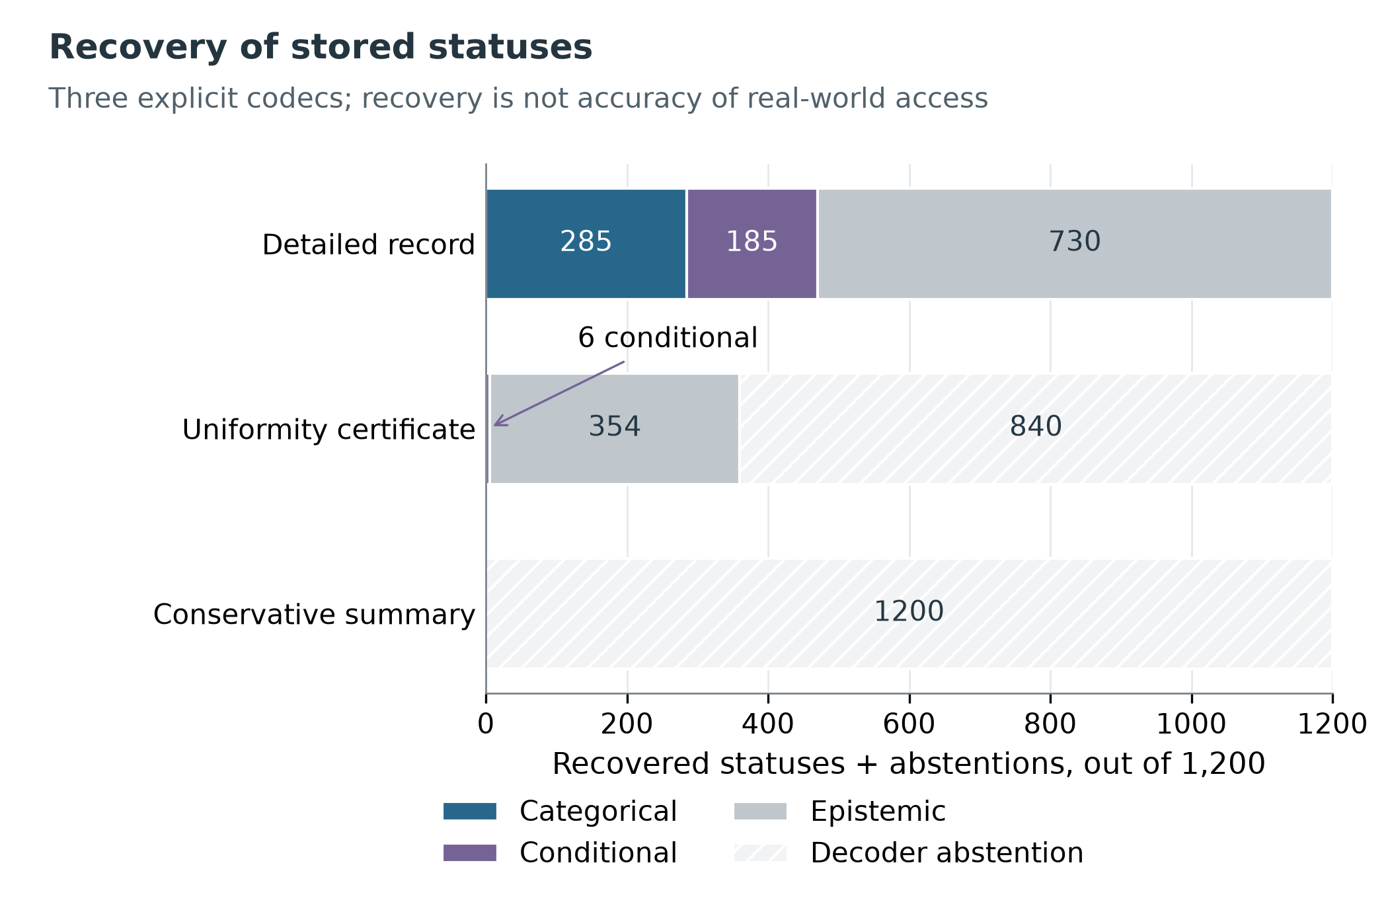
Figure 2. V1. Exact recovery of stored statuses under the specified representations. The unit is a status position in 200 six-service vectors, totaling 1,200 positions. Detailed lookup retains its own data by construction; the certificate recovers 354 unknown and six restricted positions. The conservative inverse decoder abstains where multiple possible vectors share a label. These are encoding guarantees, not factual access accuracy. Data: evaluation-results.json; English variant of fig17.
Even an oracle forced to repeat one category leaves 183/1,200 disagreements, or 15.25%. Among the 470 categorical or conditional positions, the corresponding minimum is 37/470. These quantities are defined relative to retained annotations, including their possible errors. The result does not demonstrate a universal inability to compress data: a richer code, service icons, linked prose or a reversible vector identifier changes the available information channel and therefore the comparison.
The dataset contains 473 conditional outcome records in 203 query cells. Every restricted cell has structured outcomes, but 444 branch records lack an explicit reference-scope flag and 444 lack a separate logical-compatibility flag. Different recorded statuses occur in 184 of 185 restricted cells. This shows that one outer status can conceal materially different alternatives; it does not establish that all alternatives are compatible, exhaustive or simultaneously true. The missing flags limit automated composition and are reported as a substantive deficiency of the current representation.

6.3 Frozen V1 reporting-filter sensitivity
Sensitivity analyses apply explicit reporting filters without recoding excluded cells as prohibited or expired. Both the retained denominator and the original grid remain visible. Requiring every linked source to have a substantive reading retains 968 queries and 469 categorical or conditional responses. Because a source bundle may contain an unreadable auxiliary page alongside sufficient evidence, this filter is deliberately stringent; it is not a legal adjudication of which remaining answers are correct.
Table 4. V1. Selected reporting-filter sensitivity results. “Content” is categorical plus conditional responses, not full resolution. Retained-subset percentages and full-grid percentages answer different questions.
Filter | Retained queries | Categorical | Conditional | Content / retained | Content / 1,200
Complete grid | 1,200 | 285 | 185 | 39.17% | 39.17%
All linked sources substantively read | 968 | 285 | 184 | 48.45% | 39.08%
Document date recorded | 793 | 253 | 163 | 52.46% | 34.67%
Four pilot surfaces excluded | 960 | 204 | 153 | 37.19% | 29.75%
Existing-account services only | 1,000 | 204 | 163 | 36.70% | 30.58%
Current label and explicit effective start | 52 | 28 | 23 | 98.08% | 4.25%

Excluding the four surfaces represented in the qualitative pilot leaves 960 queries and 357 categorical or conditional responses. This is a sample-composition sensitivity, not held-out validation. A filter requiring a current documentary label and explicit effective start leaves only 52 queries. Its high retained-subset content percentage illustrates why discarding missing metadata can create a misleading appearance of completeness. Seven-, 30- and 90-day observation-age filters leave the new grid unchanged because readings were recorded on the same calendar date; this does not refresh historical policy applicability.
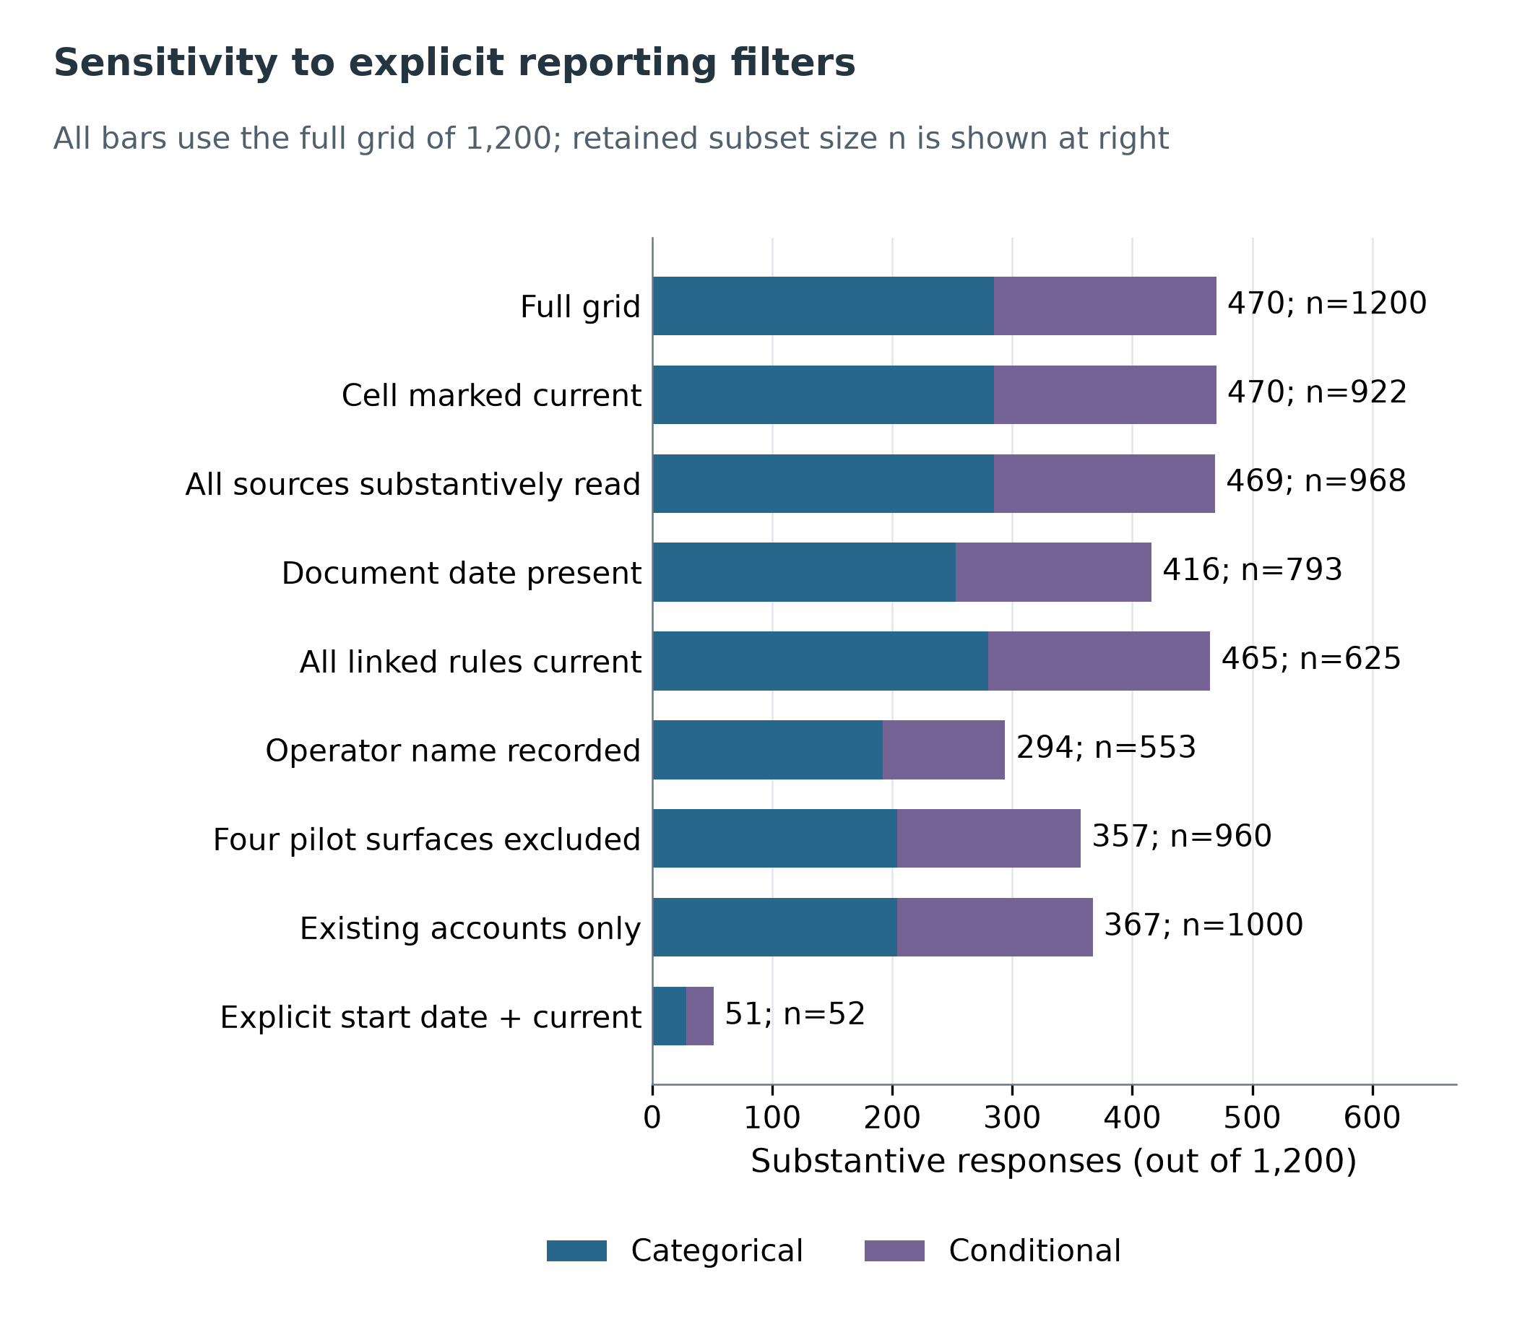
Figure 3. V1. Sensitivity to explicit reporting filters. Bars use the fixed denominator of 1,200 queries, while labels report the number retained by each filter. Categorical and conditional responses remain separate. These post-observation filters do not assign legal expiry to old pages, and a recorded operator name does not by itself establish contractual applicability. Data: statistics-v1 sensitivity table; English variant of fig19.
Deleting all query cells linked to one exact URL, in turn, removes between zero and 56 categorical or conditional responses. This is a concentration diagnostic, not a confidence interval or a forecast of website failure. Other evidence in the deleted cells might remain sufficient, but the program does not silently re-adjudicate its meaning. Such diagnostics are useful precisely because they distinguish computational dependence from substantive corroboration.

7 The V2 audit scope, units and accepted changes

7.1 Documentary coverage is a separate denominator
V2 examines ten layers for each of twenty surfaces: general terms, operator identity, geography, onboarding, spot, derivatives, fiat, staking, cryptoasset withdrawal and regulatory instruments. The resulting 200 coverage records are platform–document-layer pairs. They are distinct from the 200 platform–country pairs used in the compression experiment. Specialist searches of national registers form a separate task ledger and are not appended to the same coverage denominator.
A directly verified layer means that a specified assertion was read in a primary source; it does not mean that every contract provision or all country–product combinations were verified. Partial coverage preserves both the established part and the remaining gap. An inaccessible register card, a failed download and a search that found insufficient material are not coded as absence of a licence. V1 was not retrospectively scored under the complete V2 coverage rubric, so no percentage improvement is computed from an invented zero baseline.
The final V2 ledger contains 384 source observations at 334 exact URLs. Some relevant content was directly read in 301 observations, including full, relevant-section and partial direct readings; this is not a count of fully read contracts. At least one direct reading exists for 266 URLs, while 68 have none. The combined V1+V2 ledger contains 635 observations at 421 exact URLs. Coverage comprises 106 directly verified, 92 partial and 2 retrieval-blocked records out of 200. The regulatory layer has 118 observations and 102 conservatively matched groups; the latter is not a count of unique licences.
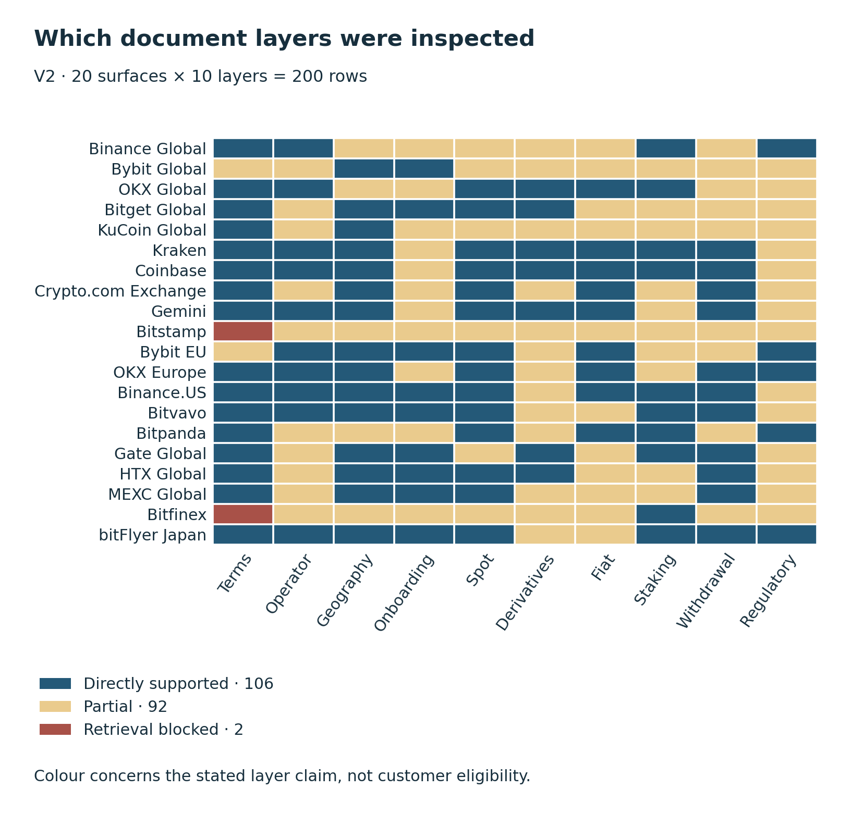
Figure 4. V2 document coverage: 106 directly supported scoped claims, 92 partial and 2 blocked retrievals across 200 surface–layer rows. Colour does not indicate service eligibility. V1 was not coded under the same coverage rubric, so no improvement percentage is estimated. Source: coverage-v2.json.
Source observations, exact URLs, entities and regulatory instruments remain different units. Repeated reading of a URL may add an observation without adding a document; a changed text at the same URL may represent a new version. Regulatory observations include authorizations, registrations, notifications, warnings, exemptions and unresolved operator assertions. Their total is not called a count of exchange licences. Conservative grouping of matched entity–instrument identifiers reduces duplicate observations but does not establish an exhaustive universe of unique permissions.
The audit checks authorship as well as hosting. A Binance announcement on the ADGM website is expressly third-party material, not a regulator-authored confirmation. Likewise, a warning about a clone must not be attributed to the genuine company identified within it. Source authority therefore cannot be inferred solely from an official domain.

7.2 Only two query responses change
For Kraken derivatives in Germany and France, the PEDSL contract provides a named route requiring both residence and physical location in the EEA. Part A § 2.10 provides a default retail classification, while §§ 2.2 and 2.9 preserve product, country and appropriateness requirements; Part D addresses derivatives. Both cells therefore change from unknown to restricted. No available branch is added. For a resident located outside the EEA, inapplicability of this contract does not establish a platform-wide prohibition; the platform-level outcome remains unknown. The conditional partition is not claimed exhaustive.
Documentary status | V1 | V2
available | 12 | 12
unavailable | 273 | 273
restricted | 185 | 187
unknown | 720 | 718
inaccessible | 10 | 10
conflicting | 0 | 0
Total | 1,200 | 1,200

The other 1,198 cells are unchanged without new cell-level adjudication, not freshly validated. The contract took effect on 1 October and was observed during the later audit; its use revises evidence for the reference frame rather than measuring two markets opening overnight. The collection window and protocol amendment explicitly separate observation, document and effective dates.
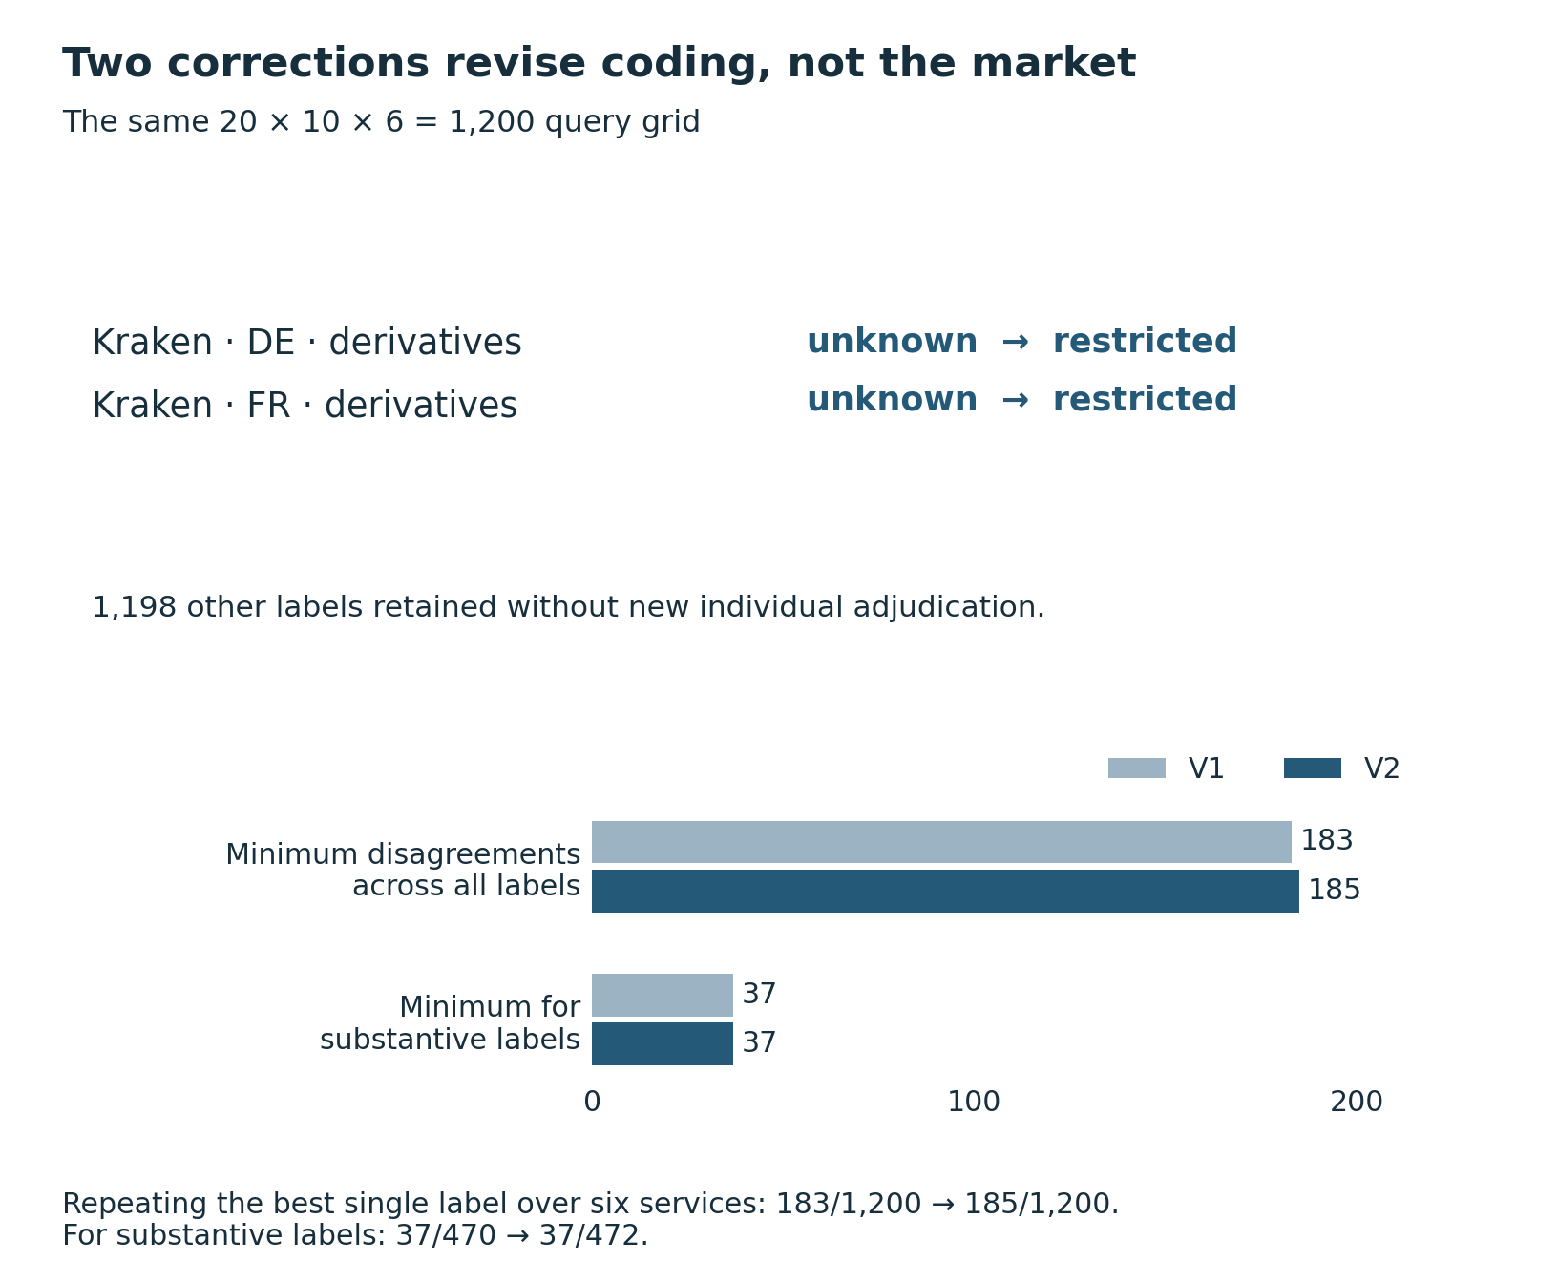
Figure 5. Two accepted Kraken unknown→restricted revisions and their arithmetic effect. The other 1,198 labels received no new individual adjudication. The lower panel shows minimum disagreements when one optimal label is repeated over each surface–country pair’s services: V1 183/1,200, V2 185/1,200; substantive labels 37/470 and 37/472. This is coding information loss, not an estimate of legal error. Sources: root-accepted-cell-patches; compression-comparison.
Recalculation on V2 preserves heterogeneity at 140/200 and 32/91 and the certificate's 360 recovered positions: 354 unknown and six restricted. The oracle minimum changes to 185/1,200 (15.42%), compared with V1's 183/1,200. Among substantive positions, the numerator remains 37 while the denominator changes from 470 to 472. The original figures in Section 6 retain V1 values; the versions are not silently combined.
The small numerical change is consistent with the audit's substantive purpose. Resolving a corporate former name, a licence's activity scope or a misleading source attribution can materially improve an explanation without changing the final country–service status. Conversely, a newly read licence should not automatically upgrade a cell whose contractual applicability remains unresolved.

7.3 Technical evidence explains mechanics
Official API documentation can establish product mechanics and interface changes. Coinbase's retirement of former Advanced Trade INTX endpoints on 1 October and migration to Global Derivatives, with some read endpoints temporarily retained for pre-migration history, identifies a technical transition; it does not establish closure of every institutional INTX route or eligibility of every API user. bitFlyer's continued FX_BTC_JPY identifier after the migration from Lightning FX to CFD illustrates why a field name cannot determine the current legal product category.
Bitfinex's Travel Rule guide and withdrawal parameter reference differ in whether information is described as mandatory or voluntary. This is a documentation mismatch, not a verified bypass. No live API call, account application, trade or transfer was performed. Technical sources remain attached to product evidence and do not supply a missing legal permission.

7.4 Incomplete evidence and hypothetical completion
The V2 grid has 718 unknown and ten inaccessible responses: 728/1,200, or 60.67%, are epistemic abstentions. The remaining 472 responses comprise 285 categorical and 187 conditional annotations. A restricted response is not a positive admission decision. Percentages conditional on the 472 substantive annotations cannot be interpreted as the prevalence of restrictions across the full frame, let alone across the world market.
Table 5. V2 completeness by service. Every row has the same denominator of 200 fixed queries. Unknown and inaccessible remain separate in the data; the last column combines them solely to display the evidence gap.
Service | Available | Unavailable | Restricted | Unknown | Inaccessible | Epistemic abstention
Onboarding | 4 | 77 | 22 | 97 | 0 | 48.5%
Spot | 4 | 47 | 31 | 118 | 0 | 59.0%
Derivatives | 0 | 56 | 29 | 105 | 10 | 57.5%
Fiat | 2 | 44 | 42 | 112 | 0 | 56.0%
Staking | 1 | 49 | 32 | 118 | 0 | 59.0%
Withdrawal | 1 | 0 | 31 | 168 | 0 | 84.0%

Missingness is connected to the collection process: unresolved identity, incomplete product scope, omitted customer predicates and obstructed retrieval can prevent a decision. The design provides no basis for treating these gaps as random, assigning them the distribution of observed labels, or imputing them as country bans. The especially high withdrawal gap concerns the difficulty of establishing an existing client's recovery route from public texts; it cannot establish that withdrawal is widely permitted or widely prohibited.
A finite completion exercise makes the inferential limit explicit. Hold every recorded available, unavailable and restricted response fixed. Replace each unknown or inaccessible response by any of those three substantive statuses. For a pair p, let n(p,s) be the retained count of substantive status s and m(p) the number of epistemic responses. Each completion adds nonnegative integers x(p,s) with sum m(p). Its optimal repeated-label disagreement is 6 minus the largest completed category count, max_s[n(p,s)+x(p,s)]. Enumerating all allocations for each pair gives the sharp range under these assumptions; pairwise extrema can be added because the exercise imposes no cross-pair constraint.
The minimum disagreement is 37/1,200 and the maximum 592/1,200, or 3.08%–49.33%. The number of heterogeneous completed pairs ranges from 32 to 199 out of 200, or 16.0%–99.5%. “Sharp” means attainable under the stated unconstrained completion exercise, not legally feasible for a jointly specified customer population. The bounds retain possible errors in the 472 fixed annotations and permit combinations that may violate common-source or contractual constraints. They are not confidence intervals, access estimates or guarantees about real people. The observed six-status value of 185 is a different object because uncertainty is itself retained as a label.
This result narrows the empirical claim. The dataset establishes loss when compressing its recorded annotations into one repeated label. It does not identify the proportion of real platform–country pairs with differing service permissions. No missing-at-random model, population-weighted estimate or human annotation accuracy is assumed to bridge that gap.
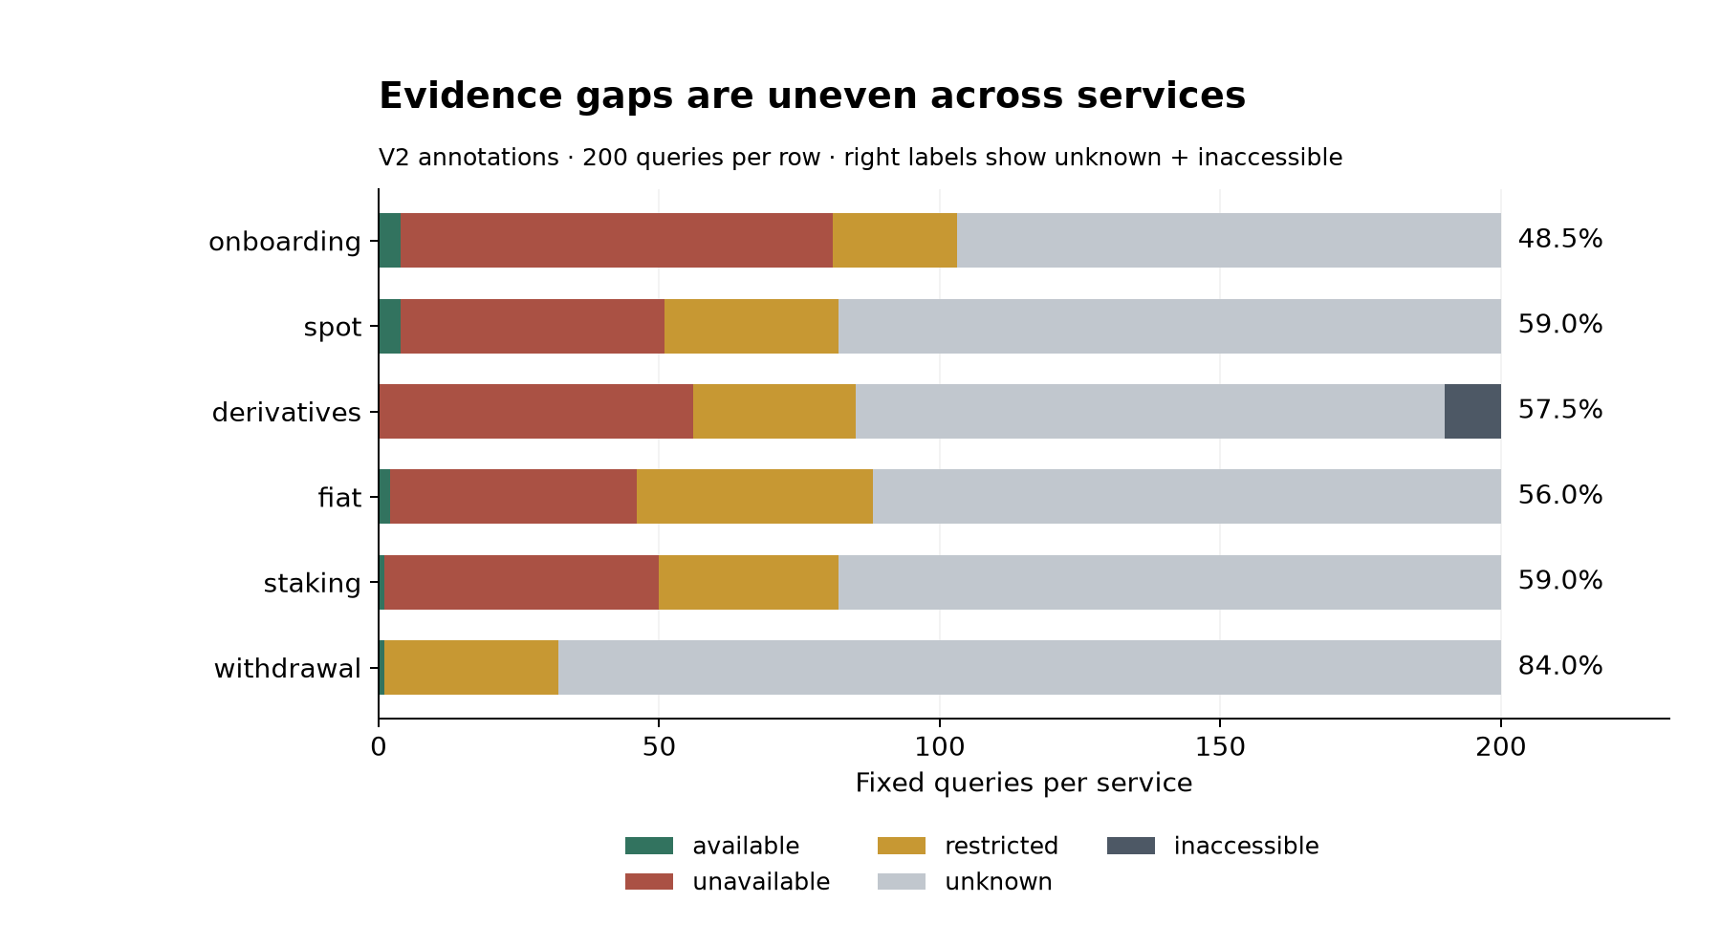
Figure 6. Evidence completeness across six services. All bars use 200 fixed queries; uncertainty is not treated as a restriction. The total of 728 epistemic responses includes 718 unknown and ten inaccessible responses.
The V2 conditional representation also remains incomplete: 477 conditional outcomes occur in 205 cells, with 448 outcomes missing a separate reference-scope flag and 448 missing a logical-compatibility flag. The V1 counts of 473, 203 and 444 reported in Section 6 refer to the earlier snapshot. Neither version supports treating its recorded branches as an exhaustive, mutually exclusive partition of customers.

8 What the primary documents change in selected cases

8.1 Binance continuity of a person, discontinuity of instruments
The current Binance Global PDF effective 27 October 2026 was obtained and relevant sections read, resolving the earlier current-contract gap. Its first page names Nest Exchange Limited, formerly Nest Services Limited, company 000032533; Nest Clearing and Custody Limited, formerly Binance (AD) Limited, company 000007529; and Nest Trading Limited, formerly BCI Limited, company 000032569. The FSRA card independently confirms NCCL's former name. The corporate number comes from the contract, not from a field displayed in that register card.
The historical Binance (AD) Limited FSP 220058 is marked withdrawn on 8 December 2025, whereas NCCL's Recognition Order 0070 is active and dated the same day. These are different instruments; their difference does not prove two unrelated legal persons. This corrects an identity inference while preserving the need to examine each instrument's scope. Conditions of the former FSP, including its customer restrictions, are not silently transferred to the recognition order.
The contract's § 1.4 defines a hierarchy involving rulebooks, specifications, notices, procedures and product terms. Geographic and product conditions in §§ 2.1–2.3 and 4.1 remain material; default retail classification under § 7.2 is not admission. A further direct reading of Nest Trading's dynamic FSRA card recovered six activities effective 5 January 2026. Its limitations prohibit holding or controlling Client Money and restrict Fiat-Referenced Token money services to Accepted Fiat-Referenced Tokens. A blank Asset Type field does not authorize every asset.
This example demonstrates why a group-level regulatory announcement is inadequate evidence for a customer route. The legal person, instrument, activity and product agreement must remain connected. ETH Staking's named Nest Trading role is evidence for that product, not every Earn product. Binance Japan and Binance.US retain their separate contractual arrangements.

8.2 Bybit internal identity tension and document priority
The read Global PDF effective 27 April 2026 names Bybit Technology Limited in its preamble but defines Company as Bybit Virtual Asset Platform Operator–L.L.C–S.P.C on page 6. The linked newer legal portals did not disclose enough text to resolve the priority problem. Neither name is chosen merely because it produces an easier licence match. A VARA record for Bybit Fintech FZE, VL/26/10/003, is a distinct legal entity and cannot validate BVAPO's claimed CMA number 20200000337; the individual CMA card remains unread.
France is absent from a later restricted-country FAQ but remains excluded in the read general PDF. The French addendum separately names BTL and gives its own terms priority. Its cessation and residual-asset procedure includes event-relative conditions and Coinhouse, not an indefinitely open withdrawal service. A newer help list therefore does not, by itself, establish renewed onboarding. The unresolved question is which current contractual route governs the customer, rather than whether one can find a positive sentence somewhere on the site.
Bybit EU GmbH is independently identifiable through FN 636180i and LEI 5299005V5GBSN2A4C303. FMA's 28 May 2025 authorisation lists a, c, d, f, j, without trading-platform operation code b. The older combined product PDF is retained as a historical source, not treated as the latest agreement for every product. A 2 November browser reading of the current product pages found an Exchange agreement marked version 4, dated 19 October 2026, and Rewards terms bearing the same body date, although both page headers display 16 October. The Margin page displays an update on 24 July 2026 while its document body remains version 1 dated 17 August 2025. These metadata are preserved separately; customer-specific commencement is not inferred from the page timestamp alone.
The newly read Exchange §§1.2 and 4.1–4.2 identify Bybit EU as counterparty and describe a synthetic liquidity view without direct matching between customers. Rewards §§3.2 and 3.7 describe a loan with transfer of title, leaving a contractual claim rather than ownership of the subscribed assets. The Margin agreement's order-process text describes borrowing cryptoassets against collateral; enabling its margin feature can still yield an ordinary spot transaction when no assets are borrowed. These contractual descriptions, rather than a familiar interface or generic Earn label, support the distinction among service structures. The reading covers the relevant introductory and mechanism clauses, not an exhaustive review of every product condition.

8.3 Gemini authorisation alongside an announced customer-service closure
The V2 recorded reading of MFSA identifies Gemini Intergalactic EU Ltd, C110029 and LEI 2138002QAMX8PPKSO715, with a CASP instrument marked Licence Authorised and issue date 20 August 2025. A separate cross-border exchange-for-funds record is dated 21 August; ESMA also contains 21 August in its authorization field. These dates are retained as distinct source events, rather than harmonized without proof. The V2 reading also distinguishes a voluntarily surrendered VFA instrument from the CASP instrument. Both MFSA detail pages resisted the 2 November reread; these claims therefore remain attributed to the retained V2 observations. The Gemini ESMA row was reread on 2 November, which verifies that later register observation rather than retrospectively authenticating either MFSA page.
Gemini's operational notice nevertheless announced closure of UK, EEA and Australian accounts on 6 April 2026, following withdrawal-only status for UK and EEA accounts from 5 March and crypto-withdrawal-only status for Australian accounts from 1 March. A blank licence-end field or an authorized company does not reopen that customer route. The two sources answer different questions, so their coexistence is not automatically coded as conflicting access evidence. Nor does a historical withdrawal window establish indefinite residual access in October.
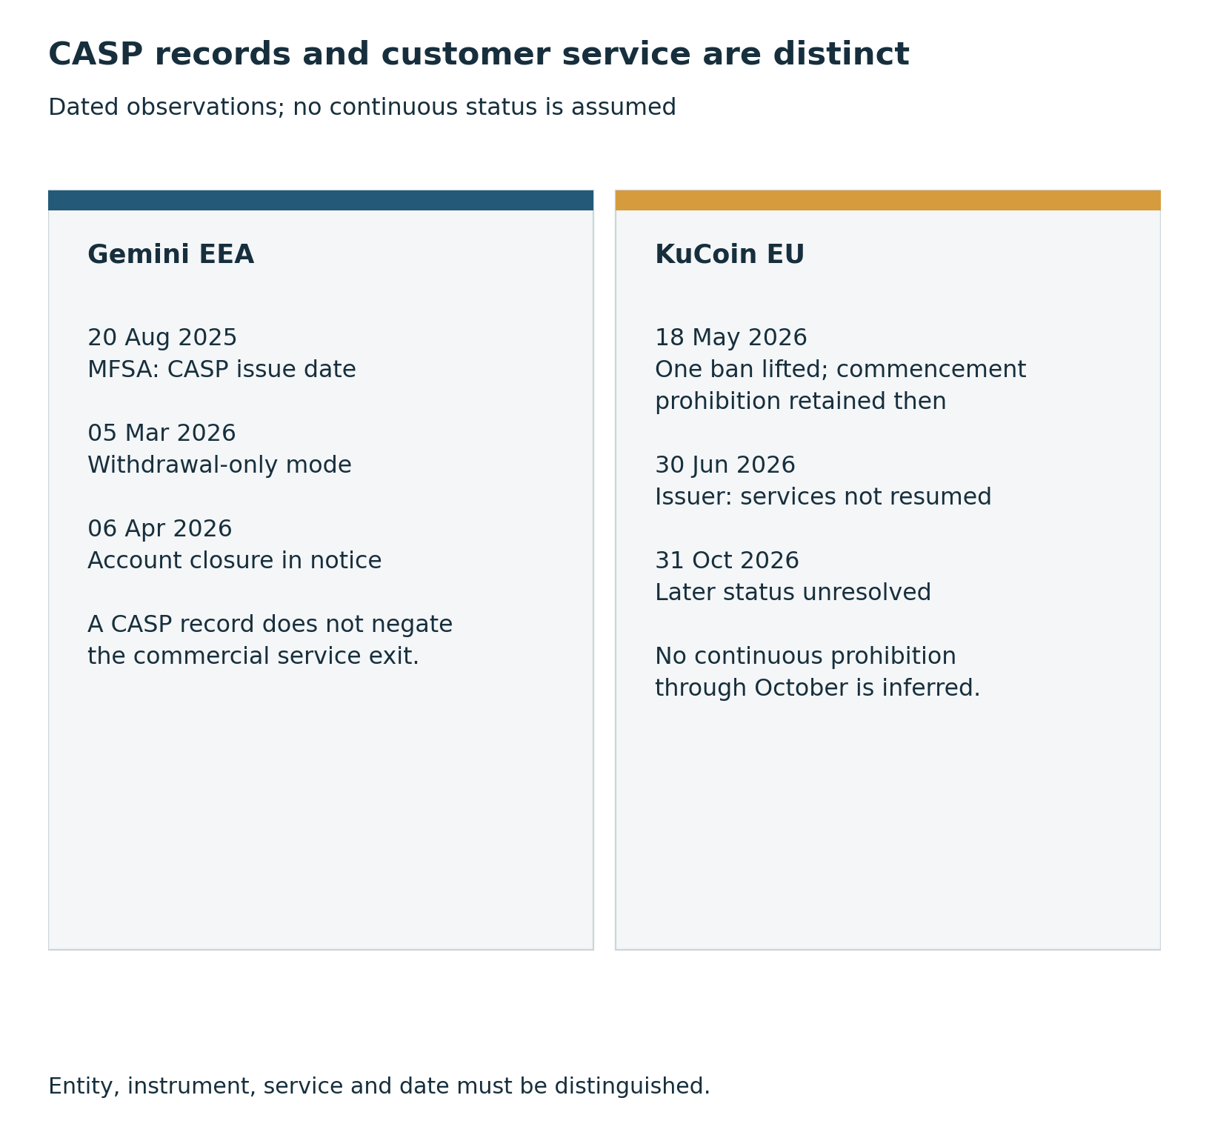
Figure 7. Two contrasts between authorisation and service. The V2 recorded MFSA CASP issue date is 20 August 2025 (the detail card could not be reread on 2 November); the ESMA date of 21 August is preserved separately, not corrected by inference. The EEA account exit follows a separate notice. FMA’s KuCoin announcement on 18 May 2026 distinguishes two prohibitions; the later position remains unresolved. Sources: V2-12-011, V2-06-015, V2-08-020, V2-08-028 and V2-12-006, V2-12-007.
The Singapore addendum supplies another distinct route through Gemini Digital Payments Singapore. Its MAS directory ID 430098 is not relabelled a licence number. The addendum excludes retail derivatives and credit or charge cards; Artemis Pte. Ltd. in a separate derivatives agreement does not inherit the payment entity's permission. This is a concrete reason to preserve regional entities even when a brand uses shared support pages.

8.4 Gate and HTX predicate ambiguity and event-relative time
Gate's Global terms use a group description rather than one exact contracting party for all services. Their geographic predicates differ: § 2.5 concerns location, § 2.10(d) expressly addresses US residence, and § 2.9 begins with represented persons or subaccounts but ends with broader wording about benefit to a restricted-territory resident. The initial reading that § 2.9 concerned only represented persons was qualified after critical review. The alternative blanket residence prohibition is not adopted without resolving that wording together with § 2.8(h).
HTX's relevant terms were read from ordinary public HTML after an extraction failure. The body version 2026-09 differs from an older page date; the current limitation is unresolved exact identity behind HTX Operators, not total unreadability of the terms. Huobi Global S.A. of Panama is named in UK proceedings and a sanctions record, but that establishes the subject of those instruments rather than the party to every HTX contract.
Four clocks must be distinguished. HTX's 16 October notice starts an individual 48-hour window after approval. Court undertakings have a horizon to 21 October 2031. OFSI General Licence INT/2024/4761108, amended 26 May 2026, expires 23 February 2028 at 23:59. Cryptoasset-payment reporting is due within 14 days after month end. The general licence's cumulative personal-remittance limit is £55,000; struck-through £50,000 belongs to the earlier text. This sanctions exemption is neither an exchange licence nor evidence that HTX will execute a given transfer.
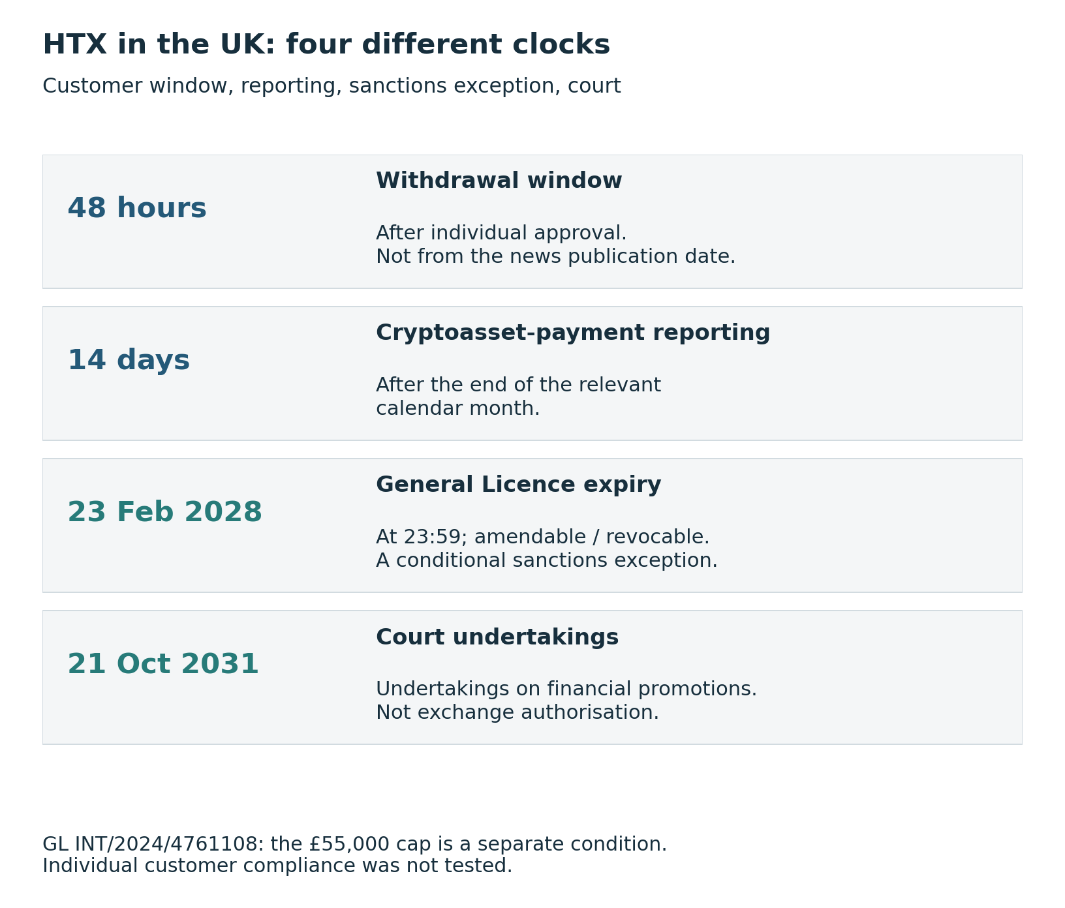
Figure 8. The four HTX UK time conditions have different triggers and scopes. The 48 hours start after approval; the 14 days for cryptoasset-payment reporting follow calendar month-end. The General Licence is a sanctions exception, not exchange authorisation; its read £55,000 cap replaces a struck-through £50,000. Sources: V2-10-016, V2-10-023, V2-10-008.

8.5 MEXC and the authority of a claimed licensing body
MEXC's 13 October 2026 agreement names MEXC (Comoros) Ltd.; that identity was already present in V1, so V2 confirms rather than discovers it. An AOFA card claims company 16265 and licence L16265/MEXC. However, a Comoros central-bank/finance-ministry warning names AOFA in its discussion of unauthorized offshore banking and financial claims. The authority of the purported issuing body is therefore a disputed link, not a resolved prudential permission.
The warning is not an individual adjudication against MEXC and does not establish worldwide illegality. Likewise, Seychelles FSA's 26 May 2026 notice names MX Global Ltd., IBC 238047, which is not silently merged with an older MEXC Global LTD number 218833. Both overstatement directions are avoided by retaining the exact subject. The French notice announces phased existing-customer restrictions beginning on 18 November, 10 December and 31 December 2026 and 22 January 2027, followed by withdrawal-only status on 25 January and the end of withdrawals on 5 March 2027. Registration closed on 28 October 2026. The existing-customer schedule remains future at the reference date; it does not justify recoding all existing services as already closed.

8.6 Other corrections that affect interpretation
Direct visual inspection of the FSA financial-instruments table confirms bitFlyer's Type I column for registration 3294, linked through corporate number 2011101068824. This resolves an earlier table-alignment gap. It does not remove product criteria: CFD eligibility specifies ages 20–80 and financial/knowledge requirements, beyond the study's generic adult profile.
For Coinbase India, tax and exchange-control residence are explicit contractual predicates. Linking a bank account permanently disables outbound cryptoasset sending even if that bank is later unlinked, while INR withdrawal remains possible. A binary withdrawal label would collapse asset direction and account history.
For KuCoin EU, FMA's 18 May 2026 notice lifts one new-business ban but states that a separate 18 February commencement prohibition remains. A bounded search found no later lifting decision; this does not establish its absence, and the current commencement status is unresolved. The regional company is not substituted for KuCoin Global.

8.7 Corrected customer and exit predicates
Renewed reading also identified narrower errors inside conditional answers. The Bitpanda UK contract's seven-day post-termination access period is a default with exceptions: § 7.8.2 extends restricted access when a product's notice or wind-down period takes longer, and § 7.8.3 retains conditions concerning open leverage positions. The corrected rule preserves settlement, compliance and staking-unbonding requirements. An unspecified customer's outer restricted status remains unchanged, but an absolute seven-day formulation is removed.
Bitvavo's § 2.13 return route is triggered by termination by Bitvavo. It does not establish the same residual route for every possible account closure. The ordinary fourteen-day period starts from receipt of valid return details and can take longer because of compliance checks or lending; trade-only assets involve a separate conversion route. Ten retained restricted withdrawal cells therefore receive a narrower conditional predicate. Neither the deadline nor the outer status is a report of a completed withdrawal.
The OKX EEA deposit-and-withdrawal-only clause in § 1.1.8 concerns noncompliant asset-referenced tokens and e-money tokens. It cannot be extended to every asset described as noncompliant with MiCA. Separately, the staking announcement expressly permits eligible new subscriptions issuing BETH or OKSOL from 16 July 2026; it does not merely continue existing positions. The revised predicates preserve account, jurisdiction and product eligibility rather than turning the new-subscription statement into universal retail availability. These two corrections affect the German and French spot and staking cells without changing their outer restricted labels.
Binance.US distinguishes active Staking Services from Soft-Staking. The former requires completion of unstaking, network unbonding and applicable processing before withdrawal; the latter keeps the balance withdrawable subject to ordinary account and asset conditions. The revised US withdrawal rule therefore removes the generic assertion that every staked balance must wait for unbonding.
The distinction between a categorical correction and a predicate correction is substantive. A stable outer count can conceal a changed answer for a particular customer or account event. V3 therefore publishes old and new values for each affected field, while preserving the original V2 inputs. A new reading of the currently served document is recorded as such; it is not represented as a byte-for-byte reconstruction of an unsaved historical web page.

9 Regulatory evidence with exact product and territorial scope

9.1 European instruments are not interchangeable
The selected ESMA comparison contains fourteen exact legal entities and ten activity codes a–j. It includes regional affiliates beyond the fixed Global surfaces; it is not fourteen fully verified members of the twenty-platform frame. An absent code means that it is not listed in that row, while a blank end date is not an explicit source status of Active. Counting activities is descriptive, not a ranking of quality.
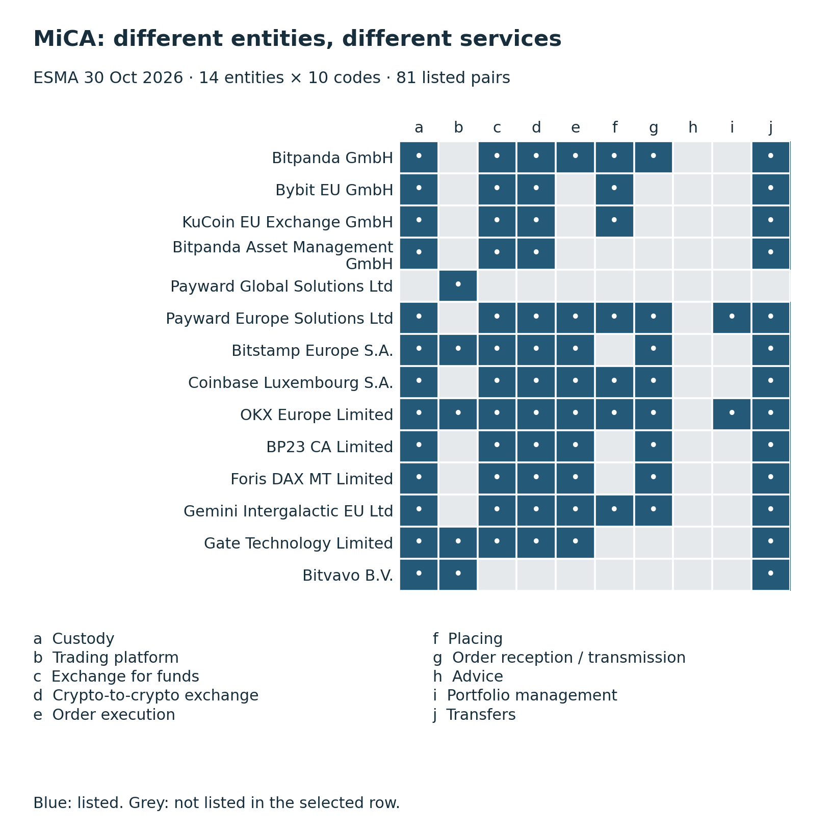
Figure 9. Fourteen selected exact ESMA entities and ten service codes, with 81 listed pairs. Grey means the code is not listed in that row, not a worldwide prohibition. The selection includes regional affiliates and is not a list of Global counterparties. Blank end dates were not converted to Active status. Sources: V2-ROOT-005, V2-ROOT-006; selected-candidate-rows.
CBI's Kraken records distinguish Payward Global Solutions Limited, C559106, with CASP code b; Payward Europe Solutions Limited, C468360, with a, c, d, e, f, g, i, j and a separate Payment Institution instrument; and Payward Ireland Limited, C453020, with an EMI instrument. PGSL's Other Jurisdictions field lists Cyprus, with Ireland as home state, consistent with CY|IE in ESMA. However, Kraken's 9 July 2026 licensing article makes an all-thirty-EEA-country claim in the exact PGSL C559106 row, not merely a group headline. The difference from the read registers remains unresolved across sources of different dates. It is not treated as proof of unlawful operation or as an access conflict for a specific query.
For OKX Europe Markets Limited, C95813/LEI 984500368874BC14E281, the home MFSA card confirms an authorized investment-firm instrument issued 17 December 2020, including Retail Clients, Professional Clients and Eligible Counterparties. A separate outgoing passport dated 5 January 2021 lists 29 EEA hosts, including Germany and France. Its sidebar Branch Termination is a distinct instrument, not termination of the home licence. The contractual split between OEM investment services and OKX Europe Limited custody, fiat and transfer functions remains necessary even after this regulatory gap is closed.
Bitvavo's DNB R163129 payment instrument illustrates product limits within an authorization. Domestic services include 3(a/b/c),5.1,5.2,6, whereas German and French passport rows include 3(a/b/c),5.1,6. The explanation limits these services to e-money tokens. Neither domestic code 5.2 nor universal fiat/banking access is copied into every host country. This is separate from the company's CASP instrument and an older PSD2 limited-range exclusion notification.

9.2 Canadian individual decisions expose omitted predicates
Payward's 1 April 2025 decision OSC 2023/0137 and 18 August 2026 variation OSC 2026/319 were read. Condition U caps net purchases over the preceding twelve months at CAD 30,000 for non-Eligible Crypto Investors and CAD 100,000 for Eligible Crypto Investors who are not Accredited Crypto Investors. That condition does not impose a numeric cap on Accredited Crypto Investors. Specified assets and residents of Alberta, British Columbia, Manitoba, Quebec and Saskatchewan are excepted. The variation adds SOL to the relevant asset list while leaving other conditions intact.
Coinbase's replacement decision 2026-86 of 1 April 2026 uses different categories. Condition C applies CAD 30,000 to specified net purchases, with exceptions including the same five provinces, permitted clients and Registered CTPs. It incorporates earlier conditions by reference; the V3 review obtained selected incorporated clauses from the official OSC bulletin, but this does not constitute exhaustive re-adjudication of every incorporated term. Marketplace-relief exceptions for several provinces are not reinterpreted as service bans. Its expiry is the earlier of two years or the investment-dealer/CIRO milestone, so 1 April 2028 is a computed upper calendar boundary, not a guaranteed operating date.
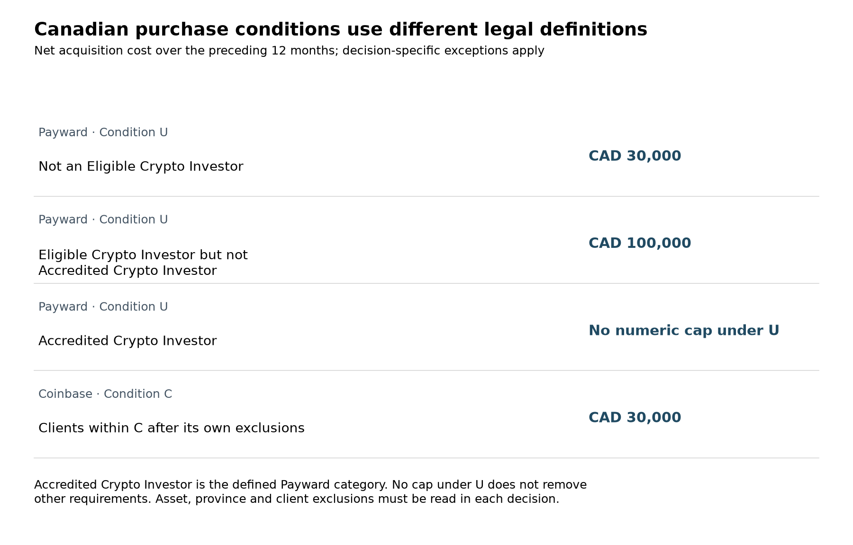
Figure 10. Comparison of Payward Condition U and Coinbase Condition C, not general Canadian eligibility. The measure is net acquisition cost during the preceding 12 months for assets outside the specified list. No cap under U does not remove other conditions. Eligible Crypto Investor and Accredited Crypto Investor classes are not transferred to Coinbase. Sources: V2-13-002, V2-13-006, V2-13-007; decision conditions and appendices.
These decisions demonstrate the value of opening the document behind a register list. Country alone omits province, investor category, asset basket, rolling purchase history and contingent expiry. Even the same numeric cap does not imply the same customer rule across two operators.

9.3 India a registration snapshot with explicit limits
The Indian Ministry of Finance's response to Lok Sabha question 5805, dated 30 March 2026, lists FIU-IND Reporting Entities as of 9 March. Annexure I identifies Peken Global Limited/KuCoin, Nest Services Limited(formerly Binance International Limited)/Binance, Bybit Fintech Limited/Bybit and Coinbase India Private Limited. It provides no individual registration numbers or full product/customer permissions. Section(f) explicitly limits FIU-IND's AML/CFT mandate and cautions against treating registration as governmental licensing, approval or protection.
The Seychelles Nest Services Limited entry is not merged with ADGM Nest Exchange Limited merely because that company also has a former Nest Services name. A corporate identifier, redomiciliation history or explicit official continuity link is missing. Bybit Fintech Limited in Seychelles likewise differs from Bybit Fintech FZE in VARA. Annexure II's historical takedown directions are undated individually; appearing in both annexes neither establishes a contradiction nor proves a current October block. The document was read in October, but its registration snapshot remains March.

9.4 Unresolved legal texts remain unresolved
FinCEN's own guidance distinguishes MSB registration from federal licensing or approval, and FCA distinguishes MLR cryptoasset registration from other permissions and consumer-protection regimes. These are classification rules, not substitutes for reading a specific entity's record. A historical enforcement notice or a CFTC financial table also retains its subject, product and reporting date.
For Russia, the Bank of Russia's current hub names laws 282-FZ and 283-FZ of 4 August 2026, but the signed 282-FZ text and transition provisions were not obtained from official publication. A separate numbered Direction 7441-U of 11 September was read; its § 9 links entry into force to ten days after official publication, while the hub notes the registration procedure. The stated RUB 300,000 parameter is therefore not declared an operative limit at the reference date merely because a numbered text exists.
The March European Commission sanctions FAQ distinguishes citizenship, residence and exceptions, but predates the July package. A July Council press release does not replace the consolidated operative text, which was not successfully read through EUR-Lex. Payment exceptions are not extended to all cryptoasset custody, and a described sanctions mechanism is not assumed activated for every possible third-country service. This gap cannot be closed by accumulating secondary summaries.

9.5 Authorisation is specific to an entity, activity and route
MiCA distinguishes the scope of the regulated product from the identity and service permissions of the provider. Financial instruments are excluded from its cryptoasset scope, so a CASP record does not itself answer an investment-services question. Article 59 distinguishes authorisation under Article 63 from the route for specified financial entities under Article 60. It requires continued compliance with authorisation conditions, specifies services in the authorisation, and provides an extension procedure for additional services. These are reasons to preserve the exact operator and service when reporting regulatory status; they are not a basis for treating every use of a cryptoasset interface as the same regulated activity.
Territorial precision also requires attention to the rule that permits cross-border activity. Article 59(7) provides Union-wide establishment and services freedoms, while Article 65 specifies the information and timing for cross-border provision. A blank, delayed or incomplete host-country field must therefore remain an evidentiary gap rather than becoming a finding of unlawful cross-border operation. Article 109 separately identifies the provider, services, intended host states, dates and supervisory measures for the public register. That structure supports preserving these fields, while their current public visibility must be assessed independently of their statutory description.
A distinct CASP authorisation is not the only possible lawful route. Article 60 permits specified financial entities to provide defined services through its notification framework. Article 61 provides a narrow exception for a third-country service initiated exclusively by the client, and excludes solicitation despite contractual disclaimers. Our rule is therefore to identify the applicable legal basis, including a supported exception, rather than to require the same document in every case. Missing information does not establish that an exception applies.

9.6 Customer conditions remain material after authorisation
The separation between provider permission and customer admission is reflected in conduct rules. MiCA Article 77(1) requires a non-discriminatory commercial policy identifying client types and applicable conditions. Trading-platform participation rules are separately constrained by Article 76(1)(d). An analyst should therefore neither infer universal admission from a licence nor assume that every exclusion in a contract is enforceable. The analysis records what the source says and distinguishes that observation from an adjudication of its validity.
This distinction is particularly important across regulatory regimes. MiFID II Article 25 separates suitability for advice and portfolio management from appropriateness for other investment services, includes a conditional execution-only exception, and requires a record of agreed rights and duties. An appropriateness warning must not automatically be recoded as a statutory trading prohibition. A provider may impose additional contractual admission criteria, but their existence and their lawfulness are separate propositions.
The PEDSL contract supplies a concrete customer predicate: the named derivative-services agreement applies to clients both resident and located in the EEA, and retains other product, country and admission conditions. Its retail classification does not itself demonstrate admission. This is sufficient to challenge a residence-only inference without claiming that the contract establishes the complete legal route or that an off-EEA customer is prohibited from all Kraken services.

9.7 What the individual Canadian decisions add
An individual decision can make a broad national summary incomplete even when the provider and country are correctly matched. The Payward decision uses defined Eligible Crypto Investor and Accredited Crypto Investor categories; the latter must not be shortened to the conventional Accredited Investor label. Condition U also depends on province, excluded assets and rolling net acquisition cost. Coinbase's replacement Condition C uses a different predicate structure, while Condition A retains prior terms unless amended. The legal lesson is not a uniform Canadian purchase cap. It is that apparently comparable permissions must be read with the incorporated definitions and conditions of each instrument.
The commercial-policy distinction has limits. Payward Conditions HH, II and KK restrict unreasonable access limitations and discrimination. Consequently, this article does not endorse unrestricted provider discretion or decide whether a particular customer could enforce an access-related right. The narrower conclusion is that a register entry alone does not establish that person's ability to use a specific service.

9.8 A scope-preserving reporting standard
I propose that an access statement identify the legal person, the relevant product or service, the territorial basis, the customer or account predicates, and the operative time. Every supporting source should be assigned to the proposition it actually establishes: regulatory capacity, a contractual condition, an operational notice, or technical functionality. A missing connection remains visible. A country summary may still be useful when it links to these qualifications; the objection is to silently extending a scoped proposition into an unconditional answer.
This proposal has practical legal relevance for regulated communications. MiCA Article 66(2) requires CASPs to provide fair, clear and non-misleading information. Preserving conditions is one analytical way to test the support for a provider's access claim. The present study does not adjudicate a violation of that provision, establish its direct applicability to independent research publishers, or derive a universal duty to use a particular database design. Extension of the proposed standard to independent catalogues is a recommendation, not a holding of existing law.
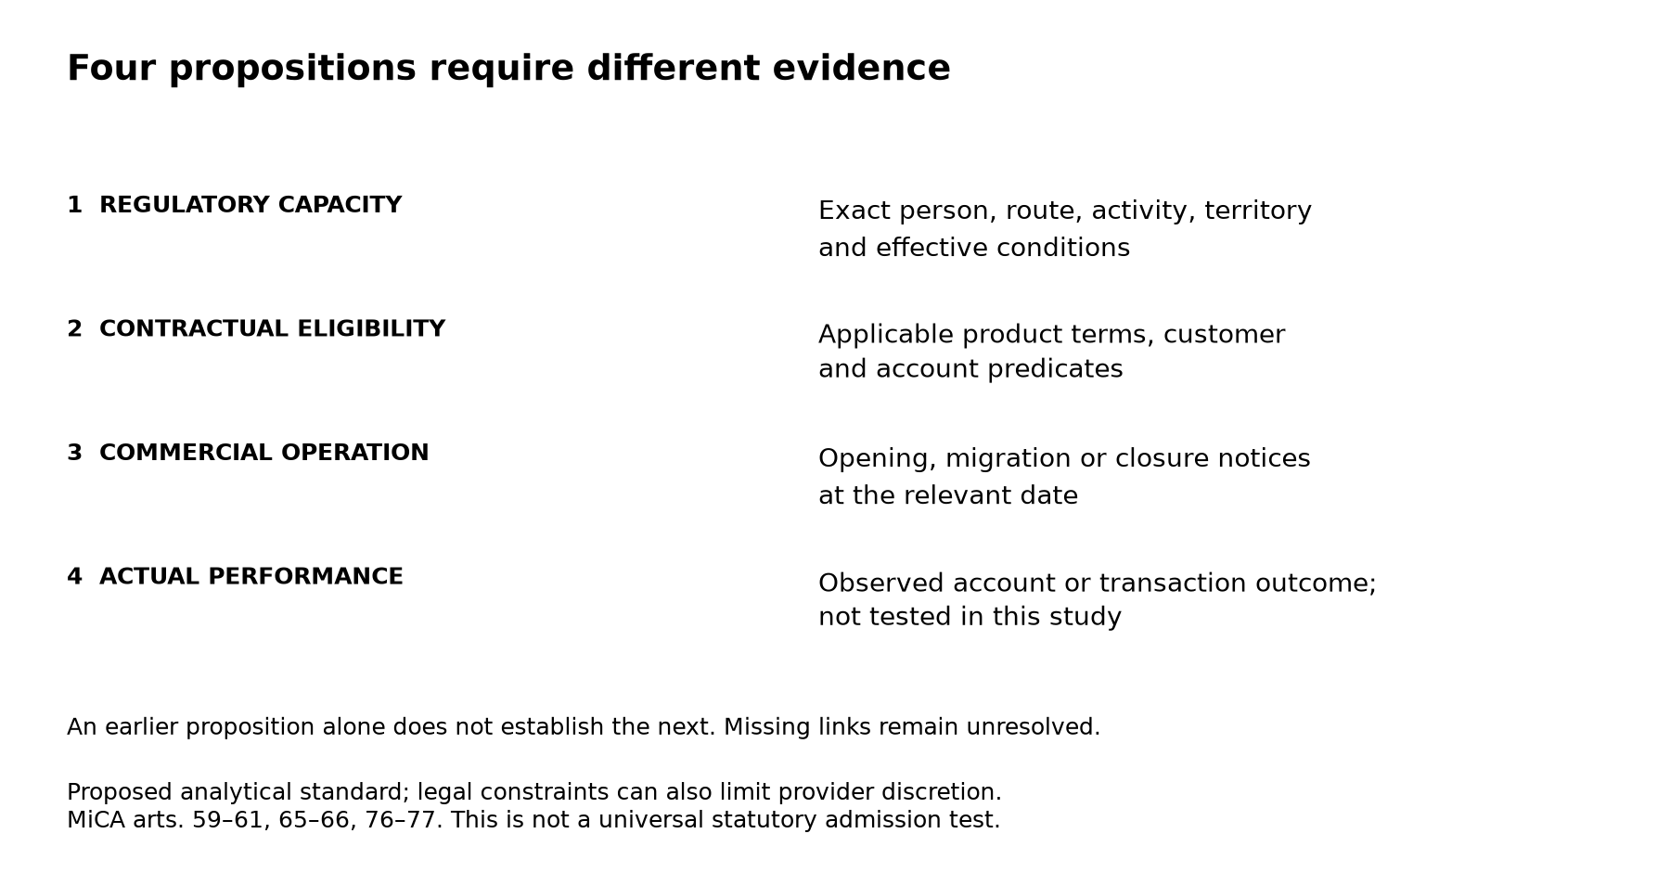
Figure 11. Regulatory capacity, contractual eligibility, commercial operation and actual performance require separate evidence. The sequence identifies questions to resolve rather than entailments. This is a proposed analytical standard; actual account performance was not tested.

9.9 Counterarguments and limits
First, a country-level label may be a navigational shorthand supplemented by accurate product detail. Our compression exercise tests the explicit repeated-label representation, not every possible summary. Second, authorisation and passporting genuinely reduce market-entry barriers; the proposed method must not recreate permission requirements that the law removes. Third, ordinary contractual uncertainty cannot be resolved by a larger number of linked pages if those pages concern different persons, products or dates. Fourth, unknown classifications may reflect our limited evidence and deliberately incomplete profile, not missing public disclosure or legal ambiguity in the market. These objections narrow the claim rather than defeat the need to retain material predicates.
The case studies establish the possibility and mechanisms of inference failure, not their market-wide frequency. The fixed-grid descriptive analysis quantifies information loss relative to its retained annotations, which remain contestable. Its high proportion of unknown responses prevents claims of comprehensive eligibility coverage. No causal claim, external legal correctness rate, independent human intercoder reliability or successful account-access rate follows from reproducing the program.

9.10 What the V3 verification establishes
Verification was separated into record integrity, computational reproduction, source-to-rule scope and renewed primary reading. These layers answer different questions. All 1,200 query records are unique and occupy the intended grid; all 635 retained source notes exist and match their recorded hashes. The 155 rule records and their query mappings were examined. The statistical reproduction covers 37 tables in paired JSON and CSV formats and 81 generated files in total. Neither a valid file hash nor successful program execution establishes the truth of an annotation or authenticity of the remote document from which a note was written.
The first renewed source pass attempted all 104 distinct URLs used by rule and query support records. Relevant primary text was read for 92; eleven routes did not disclose operative content and one disclosed only a directory. Its rule dispositions were 50 supported, 104 qualified and one unverifiable. A qualified disposition means the retained rule requires a scope, timing or applicability limitation; it does not mean that all its target customers were admitted. The 329 V2 claim records were reviewed for provenance and scope, not certified as 329 freshly and exhaustively validated legal propositions. Selected doctrinal authorities and case claims were additionally examined in separate ledgers whose denominators must not be added as if they were independent sources.
A later ordinary-browser pass revisited the eleven initially obstructed routes. Eight yielded relevant text or an explicitly linked primary document: the two Bitfinex agreements, two Bitpanda document routes, Bybit EU's General Terms, two Bitstamp pages and the Coinbase India bank-link explanation. Bybit EU's parent page yielded a document directory. The Coinbase supported-countries URL returned a missing-page response, and the Gemini derivatives article continued to redirect to the help home even through its exact-title search result. The final coverage is therefore 100 routes to relevant primary text, two directories and two unresolved article routes within that 104-URL set. These are retrieval and scoped-reading counts, not complete-document or customer-access validation counts. Dates and reading depth are retained in the supplemental ledger.
In particular, the Bitfinex derivatives terms could be read on 2 November even though the ten corresponding historical responses retain the inaccessible status recorded during collection. The terms identify a distinct counterparty and customer conditions; obtaining them later does not establish what the retrieval process observed on 30 October, nor does it independently adjudicate every customer predicate. Keeping the late source observation separate preserves the meaning of the historical compression experiment. The exchange agreement also contains an Eligible Contract Participant exception to its US prohibition; a retail research profile does not by itself establish exclusion from that statutory category. The four US annotations relying on the older prohibition note therefore remain historical labels with unresolved present applicability, rather than newly confirmed universal bans. A contemporary access atlas would require a separately dated, consistently recoded grid.
Five predicate corrections affect sixteen cells: Bitpanda UK's extended wind-down period, the asset scope and new-subscription cohort in OKX Europe, Bitvavo-initiated termination, and active staking versus Soft-Staking at Binance.US. Eight other cells had HTX rule A10-R07 linked beyond its service scope; those links were moved to contextual metadata. The complete V3 overlay contains 56 field changes: 48 corrective patches plus eight context-field additions, affecting 24 cells and five rule records. Every change records its prior value or prior absence, its replacement and its rationale. Replaying this ledger reproduces the derived records exactly. No outer status changes; 649 cells retain decision-rule links, and the V2 status totals and compression results remain unchanged.
The public evidence notes must also be distinguished from raw remote captures. Six capture references in the original acquisition material do not supply six archived primary documents in the public supplement: none of those raw files was shipped there, and two were challenge pages. All 635 publicly retained notes are authored research records. Renewed readings improve present traceability but cannot reconstruct unarchived historical page versions.
Residual limitations are explicit. The two MFSA detail cards could not be reread; selected clauses of the incorporated 2024 Coinbase decision were obtained without exhaustive adjudication of that entire instrument; the full signed Russian law and relevant EU sanctions consolidation remain unresolved in the recorded review. An operator's contractual claim to a licence is not independent register verification. No live client accounts, successful trades or withdrawals were tested, and no independent human intercoder or external peer-review assessment was performed. The supported conclusion is bounded documentary and computational reproducibility with inspectable unresolved questions, not universal factual certainty.

10 Discussion and limitations
The deeper audit changes explanations more often than final statuses. It establishes continuity between Binance legal names, recovers Nest Trading's activity restrictions, resolves bitFlyer's Type I table reading, and distinguishes Gemini's authorised entity from its announced customer-service closure. Elsewhere it strengthens the reason to withhold a conclusion: an unread CMA card cannot be replaced by a VARA permission for another entity, and a disputed issuing authority does not become verified by displaying a licence number.
This asymmetry matters for evaluating research systems. Rewarding only growth in available cells or a reduction in unknown would encourage premature identity matching and scope expansion. A useful audit can instead narrow an assertion, separate an assumed route into multiple entities, or identify an operator-authored statement hosted on a regulator's site. Its value should be assessed through the justified correction and the remaining question, not the volume of retrieved material.
The compression result is correspondingly narrow. V1's 183 and V2's 185 minimum disagreements arise when one status must be repeated across six services. They do not evaluate every possible country summary: a linked page can retain product explanations and conditions. The cases show additional losses beyond status categories. Two restricted answers can involve different residence definitions, physical location, investor classes, asset baskets or event-relative deadlines. More fields preserve these distinctions but do not prove that every stored predicate is correct or jointly satisfiable.
Licence status, commercial operation and customer eligibility should therefore be modeled as connected but separate relations. Gemini supplies an example of authorisation alongside a published closure schedule; KuCoin EU separates grant, new-business restriction and commencement; Bitvavo restricts a payment instrument by asset category. An incomplete edge in one relation need not invalidate another, but it cannot be skipped when deriving the customer's answer.
Several limitations remain. The sample is purposive; regional and global surfaces differ in architecture. Shared contracts and expanded rules make rows dependent. The ten jurisdictions are not a probability sample of the world, and no confidence interval for worldwide restriction prevalence is estimated. The incomplete reference profile deliberately leaves citizenship, physical location, legally defined residence, investor class and account history unspecified. A richer profile could resolve some branches while introducing new restrictions.
V2 is not a comprehensive recoding of all 1,200 queries. The 1,198 unchanged cells are not renewed validations, and the 106 directly verified coverage rows refer to scoped documentary assertions, not customer permissions. Reading-depth categories also differ: relevant sections, full text and partial direct readings must not be flattened into a count of fully read contracts. Multiple observations or URLs do not establish independent corroboration.
Remote texts were not systematically archived. Some evidence files are authored paraphrase notes, whose hashes authenticate those local bytes rather than the completeness of a web page. Several CSSF, AFM, NFA, CMA and CNAD routes remain unread or incomplete, as do selected product contracts and the signed Russian law. Failed retrieval does not prove absence. Observation dates do not update a dated registry snapshot or an old decision to current status.
No live onboarding, API operation, trade, deposit or withdrawal was tested. The results describe published conditions and supported documentary responses, not actual execution. Independent human coding was not conducted, and no human kappa or alpha is reported. Internal review found concrete issues but is neither independent human validation nor external peer review. Protocol amendments were recorded after some results were known and are not presented as preregistration.
A useful next study would select complete contract–entity–instrument–product–profile chains for independent blinded human coding, including consequential unresolved cases such as Bybit priority, AOFA authority, KuCoin commencement and Russian effective dates. This is a proposed next step, not a completed validation stage of the present release.

11 Reproducibility, responsibility and release status
The full local research package preserves the frozen V1 inputs, V2 source observations and claims, coverage records, regulatory observations, identity routes, adjudications, revised cells and reproducible figure data. V2 changed two outer status labels. V3 additionally corrects predicates and source links without changing those labels; the complete field-level overlay is reported in Section 9.10. Numeric claims are connected to computed tables, and documentary claims to source identifiers and clause locators. Integrity and reproduction checks establish consistency of local material; they do not certify legal interpretation or remote-source completeness.
The public computational supplement contains selected canonical V2 data and frozen V1 comparison data, source metadata and 635 evidence notes (384 V2 and 251 V1 acquisition/review observations). The V3 reproduction check matched 37 tables in paired JSON and CSV formats and all 81 generated files, including checks and manifests, byte for byte. The frozen V2 supplement also contains ten V2 figures in both languages. This is a reduced supplement: original source acquisition, full canonical-data integration, the private Holder corpus audit and regeneration of the 22 earlier V1 figures are outside its scope. The V1 figures used in the manuscripts remain included as frozen images. The supplement does not regenerate manuscript layout. A source-note hash authenticates the saved note, not the remote page; historical provenance paths may refer to deliberately omitted acquisition or integration files.
Vladislav Ch conducted the underlying research and collected the cryptoexchange data. Independent human inter-rater coding and external peer review were not performed. The two accepted V2 changes and the retention of the other 1,198 responses remain subject to the methodological boundaries stated above.
Vladislav Ch is affiliated with Holder.io. The project supplied the working corpus used in the separate historical corpus audit.
The package contains original annotations, code, figures, source links and bibliography. Public accessibility of third-party contracts or papers is not treated as unrestricted permission for mass republication. The full source ledger retains unsuccessful attempts for transparency; the manuscript distinguishes sources cited in the text from additional historical documents. The V2 preprint was publicly released on 1 November 2026 at https://github.com/Bemosha/holder-exchange-access-research/releases/tag/v2.0-preprint.1. V3 is a dated research revision. Preliminary editorial enquiries are separate from full manuscript submissions; an editorial scope response is not peer review or acceptance. No DOI or independent external peer review is claimed. Official source use does not imply endorsement by the issuing institution.
This study uses material obtained from ESMA's website. ESMA neither endorses this publication nor accepts responsibility for intellectual-property infringement or harm to third parties resulting from it. The source-reuse conditions are stated in the ESMA FAQ.

12 Conclusion
An authorisation record supports a scoped proposition about a regulated person and activity. Moving from that proposition to a customer's service eligibility requires additional, matched evidence about the product, territory, customer and operative time. The proposed inference standard preserves these boundaries while recognising alternative regulatory routes, Union-wide service freedom and the limits of public register data. It is not a universal entitlement to admission and does not convert unresolved evidence into a legal prohibition.
The retained dataset demonstrates a specific representational cost: one optimal status repeated across each platform–country pair disagrees with 185 of 1,200 V2 annotations. The 718 unknown and ten inaccessible responses prevent a prevalence estimate of actual access or actual service heterogeneity. Hypothetical completion bounds show how weak such an estimate would be even if the remaining 472 annotations were assumed correct. The legal argument therefore rests on the scope and meaning of primary authorities; the descriptive results show why preserving those distinctions matters in research representations.
Corrections to defined investor classes, evidence links and citation scope improve the audit record without creating observations that were never made. Full-record computational checks establish reproducibility of specified quantities. Renewed source readings establish only the propositions and documents recorded in the verification ledger. Live account performance, independent human coding and current applicability of unresolved routes remain outside the evidence. A scientifically useful account is one whose supported claims, corrections and unresolved boundaries can all be inspected and challenged.

OpenAI Codex assisted with source retrieval and checking, data analysis, figures, and drafting and revision. Vladislav Ch conducted the underlying research and data collection and is responsible for the analysis, citations and final text.
Apolline Blandin et al., 3rd Global Cryptoasset Benchmarking Study, at 15, 58 fig. 46 (Cambridge Ctr. for Alt. Fin. 2020), https://www.jbs.cam.ac.uk/wp-content/uploads/2021/01/2021-ccaf-3rd-global-cryptoasset-benchmarking-study.pdf.
Marilyne Ordekian et al., Raising the Bar: Assessing Historical Cryptocurrency Exchange Practices in Light of the EU’s MiCA and DORA Regulation, 59 Comput. L. & Sec. Rev., art. 106227, at 4–5 (§ 3.2.2), 14 tbl. A.7 (2025), https://discovery.ucl.ac.uk/10216847/1/Vasek_1-s2.0-S2212473X25000999-main.pdf.
Igor Makarov & Antoinette Schoar, Trading and Arbitrage in Cryptocurrency Markets, 135 J. Fin. Econ. 293 (2020), https://dspace.mit.edu/entities/publication/7f91bfb5-ba77-4d0e-9c79-ec75e104e6cc.
Tommy Crépellière, Matthias Pelster & Stefan Zeisberger, Arbitrage in the Market for Cryptocurrencies (TAF Working Paper No. 67, May 2022, rev. Dec. 2022), https://en.wiwi.uni-paderborn.de/fileadmin-wiwi/cetar/TAF_Working_Paper_Series/TAF_WP_067_CrepellierePelsterZeisberger2022_rev.pdf.
Raphael Auer & Stijn Claessens, Regulating Cryptocurrencies: Assessing Market Reactions, BIS Q. Rev., Sept. 2018, at 51, https://www.bis.org/publications/regulating-cryptocurrencies-assessing-market-reactions.
Tyler Moore, Nicolas Christin & Janos Szurdi, Revisiting the Risks of Bitcoin Currency Exchange Closure, 18 ACM Transactions on Internet Tech., no. 4, at 1 (2018), https://doi.org/10.1145/3155808.
Timnit Gebru et al., Datasheets for Datasets, 64 Commc’ns ACM 86 (2021) (author version, arXiv:1803.09010v8, §§ 1, 3), https://arxiv.org/abs/1803.09010.
Mark D. Wilkinson et al., The FAIR Guiding Principles for Scientific Data Management and Stewardship, 3 Sci. Data, art. 160018 (2016), https://pmc.ncbi.nlm.nih.gov/articles/PMC4792175/.
World Wide Web Consortium, PROV-Overview: An Overview of the PROV Family of Documents, § 1 (Paul Groth & Luc Moreau eds., W3C Working Group Note, Apr. 30, 2013), https://www.w3.org/TR/prov-overview/.
World Wide Web Consortium, Data on the Web Best Practices: Data Quality Vocabulary, abstract (W3C Working Group Note, Dec. 15, 2016), https://www.w3.org/TR/vocab-dqv/.
Matthew J. Page et al., The PRISMA 2020 Statement: An Updated Guideline for Reporting Systematic Reviews, 372 BMJ, art. n71 (2021), https://www.bmj.com/content/372/bmj.n71.
Ron Artstein & Massimo Poesio, Inter-Coder Agreement for Computational Linguistics, 34 Computational Linguistics 555 (2008), https://aclanthology.org/J08-4004/.
Binance, Binance Becomes First Crypto Exchange to Secure a Global License Under ADGM Framework, Setting a New Standard in Digital-Asset Regulation, third-party publication disclaimer (Dec. 8, 2025), https://www.adgm.com/media/announcements/binance-becomes-first-crypto-exchange-to-secure-a-global-license-under-adgm-framework-setting-a-new-standard-in-digital-asset-regulation/.
Malta Fin. Servs. Auth., MFSA Warning: OKX Clone (June 22, 2026), https://www.mfsa.mt/news-item/mfsa-warning-okx-clone-complianceeu-okx-com/.
Payward Eur. Digit. Sols. (CY) Ltd., Terms of Service, pt. A §§ 1.3, 2.2, 2.9–2.10, pt. D (effective Oct. 1, 2026), https://eu.kraken.com/legal/payward-europe-digital-solutions-cy-terms-conditions.
Coinbase, Advanced Trade REST Endpoints, INTX endpoint deprecation notice (accessed Oct. 30, 2026), https://docs.cdp.coinbase.com/coinbase-app/advanced-trade-apis/rest-api.
Coinbase, Global Derivatives Overview (accessed Oct. 30, 2026), https://docs.cdp.coinbase.com/coinbase-app/advanced-trade-apis/guides/derivatives/overview.
bitFlyer, Lightning API Documentation, Lightning FX migration and FX_BTC_JPY identifier (accessed Oct. 31, 2026), https://lightning.bitflyer.com/docs?lang=en.
Bitfinex, Withdraw Requests and the Travel Rule (accessed Oct. 31, 2026), https://docs.bitfinex.com/docs/withdraw-requests-and-the-travel-rule.
Bitfinex, Withdrawal, withdrawal request parameter descriptions (API reference, accessed Oct. 31, 2026), https://docs.bitfinex.com/reference/rest-auth-withdraw.
Nest Exchange Ltd., Nest Clearing & Custody Ltd. & Nest Trading Ltd., Binance Terms of Use, at 1 (effective Oct. 27, 2026), https://bin.bnbstatic.com/static/cms/cg08ou2ak0tn7mcplvfg/file/f7c3c8a8fbda48eaa272ff503b8c2e54c6c98ad4f0f2a1e5da3667af5962c7de.pdf.
Abu Dhabi Glob. Mkt. Fin. Servs. Regul. Auth., Public Register, Nest Clearing and Custody Ltd., Recognition Order No. 0070, previous names (as observed Oct. 31, 2026), https://www.adgm.com/public-registers/fsra/firms/recognized-bodies/nest-clearing-and-custody-limited.
Abu Dhabi Glob. Mkt. Fin. Servs. Regul. Auth., Firm Profile, Binance (AD) Ltd., Fin. Servs. Permission No. 220058, PDF p. 1 (withdrawal and limitations) (Oct. 14, 2026), https://www.adgm.com/api/FSRAC_FirmPdf/GenerateFirmProfilePdf?FirmId=165547.
FSRA, Nest Clearing and Custody Ltd., supra note 23, recognition and stipulations.
Binance Terms of Use, supra note 22, §§ 1.4, 2.1–2.3, 4.1, 7.2–7.3.
Abu Dhabi Glob. Mkt. Fin. Servs. Regul. Auth., Public Register, Nest Trading Ltd., Fin. Servs. Permission No. 260000, activities and limitations (as observed Oct. 31, 2026), https://www.adgm.com/public-registers/fsra/firms/financial-firms/nest-trading-limited-260000.
Nest Trading Ltd., ETH Staking Product Terms, § 2.3 (v1.0, Jan. 5, 2026), https://bin.bnbstatic.com/static/cms/cg08ou2ak0tn7mcplvfg/file/b6d497d5f7fc086ad597b7b4bd608cfc57cce5f2f9191bbfa84a7e17af93cd17.pdf.
Binance Japan, Terms of Use, agency arrangement (July 16, 2026) (Japanese), https://www.binance.com/ja/terms.
Binance.US, Terms of Use, identification of contracting party (June 5, 2026), https://www.binance.us/terms-of-use.
Bybit, Bybit Platform Terms and Conditions, at 1, 6 (effective Apr. 27, 2026), https://www.bybit.global/common-static/compliance/legal/BYBIT/35974902e7f42c21359e485d26bf669c.pdf.
Dubai Virtual Assets Regul. Auth., Public Register, Bybit Fintech FZE, Licence No. VL/26/10/003 (as observed Oct. 30, 2026), https://www.vara.ae/en/licenses-and-register/public-register/.
Bybit Virtual Asset Platform Operator, General Terms & Conditions, § 1.1 (operator’s statement of CMA instrument) (Jan. 23, 2026), https://www.bybit.com/common-static/compliance/legal/BYBIT/b2e1c94c53ee5e12e165919de919337e.pdf.
U.A.E. Cap. Mkt. Auth., Licensed Companies Directory, individual BVAPO record unavailable in the recorded review, https://www.uaecma.gov.ae/en/open-data/licensed-companies.aspx.
Bybit, Service Restricted Countries (Oct. 16, 2026), https://www.bybit.com/en/help-center/article/Service-Restricted-Countries.
Bybit, Addendum to Terms of Service for French Users, §§ 1.2–1.3, 2 (accessed Oct. 31, 2026), https://www.bybit.com/common-static/compliance/legal/BYBIT/fd62abedfea5943483bdfeb72e9d0ad9.pdf.
Austrian Fin. Mkt. Auth., Granting of Authorisation: Bybit EU GmbH, authorisation decision of May 28, 2025 (May 30, 2025), https://www.fma.gv.at/en/granting-of-authorisation-bybit-eu-gmbh/.
Bybit EU GmbH, Agreement for Exchanging Crypto-Assets for Funds or Other Crypto-Assets, §§ 1.2, 2.1, 4.1–4.2, PDF pp. 1–3 (v4, document dated Oct. 19, 2026), https://www.bybit.eu/en-EU/legal/terms-and-conditions/Agreement-for-Exchanging-Crypto-Assets-for-Funds-or-other-Crypto-Assets.
Bybit EU GmbH, Agreement for Bybit Rewards, §§ 2.1, 3.2, 3.7, PDF pp. 1–2 (document dated Oct. 19, 2026), https://www.bybit.eu/en-EU/legal/terms-and-conditions/Agreement-for-Bybit-Rewards.
Bybit EU GmbH, Margin Trading Service Agreement, Introduction, Eligible Users & Order Process, PDF pp. 1–3 (v1, document dated Aug. 17, 2025), https://www.bybit.eu/en-EU/legal/terms-and-conditions/Margin-Trading-Service-Agreement.
Malta Fin. Servs. Auth., Financial Services Register, Gemini Intergalactic EU Ltd., C110029, CASP and VFA instruments (as observed Oct. 31, 2026), https://fsr.mfsa.mt/Licences/ViewLicence?id=CfDJ8IAboHK1LPZJohldALoYHcahqIyRWx7RWPl_2J7zLV1Nyk2fhoZc3cmwK_QmHp_C1FJrlBnQf_OxC2GiduvS-u22PqkqPLX9jVmGGmbn1KrtjcoCxmKuYu-jmy9wGbbl_Q.
Malta Fin. Servs. Auth., Financial Services Register, Gemini Intergalactic EU Ltd., C110029, cross-border exchange-for-funds record (as observed Oct. 31, 2026), https://fsr.mfsa.mt/Licences/ViewLicence?id=CfDJ8IAboHK1LPZJohldALoYHcbwsEII4DIjnTpvOOi1hWFIBoJ40TmvFuDXGjGq1U-EXPAtPFIVEXMvtq8LKMJv2ZR8qg0QZC0tNBbSC0v4IJdRlXF1UTFacKW3qggXKYVIqg.
Eur. Sec. & Mkts. Auth., Interim MiCA Register: Crypto-Asset Service Providers, Gemini Intergalactic EU Ltd., LEI 2138002QAMX8PPKSO715 (Oct. 30, 2026 register comparison), https://www.esma.europa.eu/sites/default/files/2024-12/CASPS.csv.
Gemini, Gemini Closing Accounts in the UK, EU and Australia: Everything You Need to Know, account closure and residual funds (accessed Oct. 31, 2026), https://support.gemini.com/hc/en-us/articles/46255474469275-Gemini-closing-accounts-in-the-UK-EU-and-Australia-Everything-you-need-to-know.
Gemini, Singapore Addendum, §§ 1.1, 5.3–5.4 (Oct. 19, 2026), https://www.gemini.com/legal/singapore-addendum.
Monetary Auth. of Sing., Financial Institutions Directory, Gemini Digital Payments Pte. Ltd., institution no. 430098, activities (as observed Oct. 30, 2026), https://eservices.mas.gov.sg/fid/institution/detail/430098-GEMINI-DIGITAL-PAYMENTS-SINGAPORE-PTE-LTD.
Gemini, Derivatives User Agreement, § 1.4 (Mar. 24, 2025), https://www.gemini.com/artemis/legal/user-agreement.
Gate, User Agreement, §§ 1.1, 2.5, 2.8(h), 2.9, 2.10(d) (July 22, 2026), https://www.gate.com/legal/user-agreement.
HTX, Platform User Agreement, definition of HTX Operators (Sept. 2026 version), https://www.htx.com/en-us/about/agreement/.
Fin. Conduct Auth. v. Huobi Glob. S.A., Claim No. FS-2025-000015, Tomlin Order, at 1 (caption and parties) (High Ct. of Just., Bus. & Prop. Div., Oct. 27, 2026) (Eng. & Wales), https://www.fca.org.uk/publication/documents/tomlin-order-deputy-master-holden-27-october-2026.pdf.
HM Treasury, Off. of Fin. Sanctions Implementation, Financial Sanctions Notice: Russia, Huobi Global S.A. entry (May 26, 2026), https://assets.publishing.service.gov.uk/media/6a1578669819be865f421cf1/Sanctions_Notice_Russia_26_May_2026.pdf.
HTX, Notice on Services for UK Users, 48-hour withdrawal window after individual approval (Oct. 16, 2026), https://www.htx.com/support/65046382061950/.
Huobi Glob. S.A., Claim No. FS-2025-000015, Tomlin Order, recital immediately before ¶ 1 and sched. A–B.
HM Treasury, Off. of Fin. Sanctions Implementation, General Licence No. INT/2024/4761108, Personal Remittances, ¶¶ 3, 4.4, 5A, 7, 9–10 (amended May 26, 2026), https://assets.publishing.service.gov.uk/media/6a15541e0026f30a6d421ce1/INT.2024.4761108_GL_2026.05.26_amendment.pdf.
MEXC, User Agreement, identification of contracting party (Oct. 13, 2026), https://www.mexc.com/terms.
Anjouan Offshore Fin. Auth. (self-described), Licence Verification: MEXC (Comoros) Ltd., claimed licence no. L16265/MEXC, company no. 16265 (as observed Oct. 31, 2026), https://anjouanofa.org/register/mx-global-ltd-mexc/.
Banque Centrale des Comores, Communiqué sur l’exercice illégal d’activités bancaires offshores (Dec. 10, 2025) (republished by the Ministry of Finance), https://finances.gouv.km/actualite_post/communique-de-la-banque-centrale-des-comores-sur-lexercice-illegal-dactivites-bancaires-offshores/.
Fin. Servs. Auth. Sey., FSA Takes Enforcement Action Against MX Global Ltd. for Unlicensed Virtual Asset Services Operations, identification and regulatory breaches (May 26, 2026), https://fsaseychelles.sc/news/press-releases/fsa-takes-enforcement-action-against-mx-global-ltd-for-unlicensed-virtual-asset-services-operations.
MEXC, MEXC to Wind Down Services for Users in France, Wind-Down Timeline and Key Dates (Oct. 28, 2026), https://www.mexc.com/announcements/article/mexc-to-wind-down-services-for-users-in-france-17827791539394.
Fin. Servs. Agency of Japan, Register of Financial Instruments Business Operators, PDF p. 52, registration no. 3294 (Sept. 30, 2026) (Japanese), https://www.fsa.go.jp/menkyo/menkyoj/kinyushohin.pdf.
bitFlyer, Trading Eligibility Criteria, CFD criteria (Japanese, accessed Oct. 31, 2026), https://bitflyer.com/ja-jp/trading-requirements.
Coinbase, India User Agreement, §§ 3.1, 4.1 (accessed Oct. 30, 2026), https://www.coinbase.com/de/legal/user_agreement/india.
Coinbase, Cannot Send Crypto After Adding a Bank Account (accessed Nov. 2, 2026), https://help.coinbase.com/en-in/coinbase/trading-and-funding/sending-or-receiving-cryptocurrency/cant-send-crypto-india.
Austrian Fin. Mkt. Auth., FMA Lifts Ban on New Business for KuCoin EU Exchange GmbH, However Commencement of Business Operations Remains Prohibited (May 18, 2026), https://www.fma.gv.at/en/fma-lifts-ban-on-new-business-for-kucoin-eu-exchange-gmbh-however-commencement-of-business-operations-remains-prohibited/.
Bitpanda Broker UK Ltd., User Agreement, §§ 7.8.1–7.8.3, at 21–22 (v1.1.2), https://cdn.bitpanda.com/terms-and-conditions/user-agreement-bitpanda-bitpanda-uk-ltd-en-1.1.2.pdf.
Bitvavo B.V., User Agreement, §§ 2.11–2.15, 2.19, 4.10 (May 7, 2026 version), https://bitvavo.com/en/terms.
OKX Europe Ltd., Terms of Service, §§ 1.1.8, 3.5, https://www.okx.com/en-eu/help/terms-of-service-eea.
OKX, OKX EEA to Launch BETH and OKSOL Liquid Staking, Key Dates and What You Need to Do, https://www.okx.com/en-au/help/okx-eea-to-launch-beth-and-oksol-liquid-staking.
Binance.US, Staking on Binance.US FAQ, Staking Services, unstaking and Soft-Staking, https://support.binance.us/en/articles/9842936-staking-on-binance-us-faq.
ESMA, Interim MiCA Register, supra note 43, selected entity and service fields.
Cent. Bank of Ir., Registers, Payward Global Solutions Ltd., Ref. No. C559106, CASP services and other jurisdictions (as observed Oct. 31, 2026), https://registers.centralbank.ie/FirmRegisterDataPage.aspx?firmReferenceNumber=C559106&register=80.
Cent. Bank of Ir., Registers, Payward Europe Solutions Ltd., Ref. No. C468360, Article 63 CASP record (as observed Oct. 31, 2026), https://registers.centralbank.ie/FirmRegisterDataPage.aspx?firmReferenceNumber=C468360&register=80.
Cent. Bank of Ir., Registers, Payward Europe Solutions Ltd., Ref. No. C468360, payment institution record (as observed Oct. 31, 2026), https://registers.centralbank.ie/FirmRegisterDataPage.aspx?firmReferenceNumber=C468360&register=61.
Cent. Bank of Ir., Registers, Payward Ireland Ltd., Ref. No. C453020, electronic money institution record (as observed Oct. 31, 2026), https://registers.centralbank.ie/FirmRegisterDataPage.aspx?firmReferenceNumber=C453020&register=63.
Kraken, How Kraken Is Regulated, Payward Global Solutions Ltd., C559106 entry (July 9, 2026), https://www.kraken.com/learn/how-kraken-is-regulated.
Malta Fin. Servs. Auth., Financial Services Register, OKX Europe Markets Ltd., C95813, investment firm, clients and instruments (as observed Oct. 31, 2026), https://fsr.mfsa.mt/Licences/ViewLicence?id=CfDJ8IAboHK1LPZJohldALoYHcZHUmp5eT58aSXPZ3uA5qu0pdfCEd3MxrpUSnPJOesLciA3zYRBY31tCegkslI2VqyYjHYmqIWX7IdPuKYXCHsAqg9L_znKqvyYwwE0f8-VeA.
Malta Fin. Servs. Auth., Financial Services Register, OKX Europe Markets Ltd., C95813, outgoing investment-firm passport, host states (as observed Oct. 31, 2026), https://fsr.mfsa.mt/Licences/ViewLicence?id=CfDJ8IAboHK1LPZJohldALoYHcZe7284QtvNqHBqdPQO_7tyfCEBkYUJGPnm_F225BsYP8kO4lDqceQa0NBxZWcu5u04nDtmWv7pbmizG58T4b9RJwzHMgv67eGD8l8P8sUDeQ.
OKX Europe Market Ltd., Terms of Service, § 1.9 (Oct. 2, 2026), https://www.okx.com/en-gb/help/okx-europe-market-ltd-oem-terms-of-service.
De Nederlandsche Bank, Public Register, Bitvavo B.V., No. R163129, Vergunningen and EU-paspoort (Germany and France), EMT limitation (as observed Oct. 31, 2026), https://www.dnb.nl/openbaar-register/registerdetailpagina/?registerCode=WFTBI&relationNumber=R163129.
Id., Toelichting and Kennisgevingen.
In re Payward Canada Inc. & Payward, Inc., OSC File No. 2023/0137, Decision, condition U (Ont. Sec. Comm’n, Apr. 1, 2025) (Can.), https://www.securities-administrators.ca/wp-content/uploads/2025/04/Payward-Canada-decision-document-signed-dated-April-1-2025.pdf.
In re Payward Canada Inc. & Payward, Inc., OSC File No. 2026/319, Variation Decision, representations 3–5, sched. A (Ont. Sec. Comm’n, Aug. 18, 2026) (Can.), https://fcaa.gov.sk.ca/public/CKeditorUpload/Securities/Exemptions/2026/Payward_Canada_Inc_et_al_Specified_Crypto_Asset_Relief_(Solana)_August_18_2026.pdf.
In re Coinbase Canada Inc. & Coinbase, Inc., (2024) 47 O.S.C.B. 3081, condition XXI, app. B (Ont. Sec. Comm’n, Apr. 3, 2024) (Can.), https://www.osc.ca/sites/default/files/2024-04/20240411_oscb_2715.pdf.
In re Coinbase Canada Inc. & Coinbase, Inc., OSC File No. 2026-86, Decision, conditions A, C, app. B, expiry provision (Ont. Sec. Comm’n, Apr. 1, 2026) (Can.), https://fcaa.gov.sk.ca/public/CKeditorUpload/Securities/Exemptions/2026/Coinbase_Canada%2C_Inc_NI_21-101%2C_NI_23-101%2C_NI_31-103_and_MI_96-101_April_1%2C_2026.pdf.
Coinbase Canada, (2024) 47 O.S.C.B. 3081, condition XXI, app. B (selected incorporated terms).
Gov’t of India, Ministry of Fin., Dep’t of Econ. Affs., Regulation of Virtual Digital Assets, Lok Sabha Unstarred Question No. 5805, answer (f), annex. I, entries 41, 47–49 (Mar. 30, 2026), https://sansad.in/getFile/loksabhaquestions/annex/187/AU5805_lMTYNK.pdf?source=pqals.
Fin. Crimes Enf’t Network, Alert No. FIN-2024-Alert005, at 6 (Dec. 18, 2024), https://www.fincen.gov/system/files/2024-12/Alert-FinCEN-Scams-FINAL508.pdf.
Fin. Conduct Auth., Cryptoassets: AML/CTF Regime, Registration and Consumer Protections (Feb. 12, 2026), https://www.fca.org.uk/firms/financial-crime/money-laundering-terrorist-financing/cryptoassets-aml-ctf-regime.
Commodity Futures Trading Comm’n, Selected FCM Financial Data as of August 31, 2026, https://www.cftc.gov/sites/default/files/2026-10/01%20-%20FCM%20Webpage%20Update%20-%20August%202026.pdf.
Bank of Russia, Запуск рынка криптовалют [Launch of the Cryptocurrency Market], legislation and registration status (accessed Oct. 30, 2026), https://cbr.ru/develop/cryptocurrency/.
Bank of Russia, Direction No. 7441-U, § 9 (Sept. 11, 2026) (Russ.), https://cbr.ru/Crosscut/LawActs/File/12244.
Federal Law No. 282-FZ of Aug. 4, 2026, Official Internet Portal of Legal Information, Document No. 0001202608040007 (Russ.), signed text unavailable in the recorded review, https://publication.pravo.gov.ru/document/0001202608040007.
Eur. Comm’n, Frequently Asked Questions on the Provision of Payment Services Concerning Sanctions Against Russia, questions 1–7 (Mar. 13, 2026), https://finance.ec.europa.eu/document/download/8b0e76f4-6a5e-4fd3-a85e-04d7ecdfe340_en?filename=faqs-sanctions-russia-payments-services_en.pdf.
Council of the Eur. Union, 21st Package of Sanctions: EU Hits Russian Energy, Financial Services and Crypto Hard, financial services section (July 23, 2026), https://www.consilium.europa.eu/en/press/press-releases/2026/07/23/21st-package-of-sanctions-eu-hits-russian-energy-financial-services-and-crypto-hard/.
Council Regulation (EU) No. 833/2014, EUR-Lex, CELEX 02014R0833-20260724, July 24, 2026 consolidation unavailable in the recorded review, https://eur-lex.europa.eu/legal-content/EN/TXT/?uri=CELEX:02014R0833-20260724.
Regulation (EU) 2023/1114 of the European Parliament and of the Council of 31 May 2023 on Markets in Crypto-Assets, art. 2(4)(a), 2023 O.J. (L 150) 40 [hereinafter MiCA], https://www.esma.europa.eu/publications-and-data/interactive-single-rulebook/mica/article-2-scope.
MiCA, art. 59(1), (4), (6)–(8), https://www.esma.europa.eu/publications-and-data/interactive-single-rulebook/mica/article-59-authorisation.
Id. art. 59(1), (4), (6)–(8).
MiCA, art. 65(1), (4), https://www.esma.europa.eu/publications-and-data/interactive-single-rulebook/mica/article-65-cross-border-provision-crypto.
MiCA, art. 109(5)–(7), https://www.esma.europa.eu/publications-and-data/interactive-single-rulebook/mica/article-109-register-crypto-asset-white.
MiCA, art. 60(1)–(8), especially (3), (8), https://www.esma.europa.eu/publications-and-data/interactive-single-rulebook/mica/article-60-provision-crypto-asset-services.
MiCA, art. 61(1)–(2), https://www.esma.europa.eu/publications-and-data/interactive-single-rulebook/mica/article-61-provision-crypto-asset-services.
MiCA, art. 77(1), https://www.esma.europa.eu/publications-and-data/interactive-single-rulebook/mica/article-77-exchange-crypto-assets-funds-or.
MiCA, art. 76(1)(d), https://www.esma.europa.eu/publications-and-data/interactive-single-rulebook/mica/article-76-operation-trading-platform-crypto.
Directive 2014/65/EU of the European Parliament and of the Council of 15 May 2014 on Markets in Financial Instruments, art. 25(2)–(5), 2014 O.J. (L 173) 349, https://www.esma.europa.eu/publications-and-data/interactive-single-rulebook/mifid-ii/article-25-assessment-suitability-and.
PEDSL Terms, supra note 16, pt. A §§ 1.1, 1.3, 2.2, 2.9–2.10, pt. D.
Payward Canada, OSC File No. 2023/0137, Interpretation (b), (i), conditions U, HH–KK, PDF pp. 4–5, 35, 37.
Coinbase Canada, OSC File No. 2026-86, conditions A, C, D, H, app. B.
Payward Canada, OSC File No. 2023/0137, Interpretation (b), (i), conditions U, HH–KK, PDF pp. 4–5, 35, 37.
MiCA, art. 66(2), https://www.esma.europa.eu/publications-and-data/interactive-single-rulebook/mica/article-66-obligation-act-honestly-fairly.
Eur. Sec. & Mkts. Auth., Frequently Asked Questions, reuse of ESMA website content, https://www.esma.europa.eu/contact-help/faqs.

